“Malware detection method to detect unknown malwaress using deep learning”
Abstract
Relevance of the Thesis: The increasing reliance on digital systems in both personal and enterprise environments has led to a rapid escalation in cyber threats, particularly from malware. Traditional malware detection techniques, such as signature-based and heuristic-based approaches, have become less effective against sophisticated and evolving cyber threats, including polymorphic and zero-day malware. Consequently, advanced detection methodologies leveraging artificial intelligence, particularly deep learning, have gained significant attention.
This thesis focuses on developing a deep learning-based malware detection method to identify previously unknown malicious software. The significance of this research lies in its potential to improve the accuracy and adaptability of malware detection systems, reducing the dependency on manually curated threat signatures and enabling real-time identification of emerging cyber threats. By integrating advanced machine learning techniques with behavioral and static malware analysis, this study aims to contribute to the ongoing efforts in enhancing cybersecurity frameworks.
Furthermore, the research aligns with the growing demand for AI-driven security solutions, offering practical implications for cybersecurity practitioners, organizations, and developers of intrusion detection systems. The findings of this thesis may support the development of more resilient and intelligent security mechanisms capable of countering modern malware threats more efficiently.
Objective of the Thesis: The objective of this thesis is to develop an advanced malware detection method capable of identifying unknown and evolving threats using deep learning techniques. Traditional signature-based and heuristic-based detection systems struggle to detect sophisticated malware, such as polymorphic and zero-day threats. This research aims to overcome these limitations by leveraging artificial intelligence to improve accuracy and adaptability. The study will analyze existing malware detection techniques, explore deep learning models like convolutional and recurrent neural networks, and develop a hybrid detection framework integrating static and dynamic analysis. Additionally, the performance of the proposed model will be evaluated using real-world datasets to compare its accuracy, efficiency, and robustness against conventional detection methods.
This research also seeks to provide practical insights for enhancing cybersecurity applications. By implementing AI-driven malware detection, organizations can improve proactive threat mitigation and reduce reliance on manually curated threat signatures. The findings of this thesis will contribute to the development of more resilient and intelligent security mechanisms capable of countering modern malware threats effectively. Ultimately, the study aims to bridge the gap between traditional detection approaches and emerging AI-driven security solutions, ensuring a more adaptive and efficient defense against cyber threats.
Research Methods: The research adopts a structured approach to developing and evaluating an AI-driven malware detection system. It begins with an extensive literature review of existing malware detection techniques, including signature-based, behavior-based, heuristic-based, and machine learning-based methods. This review helps identify the strengths and limitations of traditional approaches, forming the foundation for selecting an optimal deep learning model. The study then employs a hybrid methodology, combining static and dynamic malware analysis techniques to extract relevant features for classification. Feature engineering techniques, such as opcode analysis, API call monitoring, and network behavior tracking, are applied to enhance detection accuracy.
The proposed deep learning model is designed, trained, and tested using publicly available and real-world malware datasets. Various deep learning architectures, including convolutional neural networks (CNNs) and recurrent neural networks (RNNs), are explored and optimized for improved performance. The model's effectiveness is assessed using performance metrics such as accuracy, precision, recall, F1-score, and false-positive rate. Additionally, comparative analysis is conducted against traditional malware detection methods to highlight the improvements achieved through AI integration. The findings of this research contribute to developing more adaptive and resilient malware detection systems capable of identifying evolving cyber threats.
Data Sources: This thesis utilizes a combination of publicly available and real-world malware datasets to develop and evaluate the proposed detection model. The primary data sources include established malware repositories such as VirusTotal, Malicia Dataset, and the Microsoft Malware Classification Challenge dataset. These datasets provide a diverse range of malware samples, including trojans, ransomware, worms, and polymorphic malware, ensuring a comprehensive evaluation of the detection model. Additionally, publicly accessible cybersecurity research databases and reports from organizations like the MITRE ATT&CK framework and the National Institute of Standards and Technology (NIST) are used to support the study with up-to-date threat intelligence.
To enhance the robustness of the research, real-time malware activity logs and network traffic data from controlled sandbox environments, such as Cuckoo Sandbox and Hybrid Analysis, are also incorporated. These dynamic analysis tools allow for the extraction of behavioral indicators, including API call sequences, file system modifications, and network interactions. By leveraging both static and dynamic data sources, this thesis ensures a well-rounded approach to malware detection, enabling the development of a more accurate and adaptive AI-driven security solution.
Limitations of the Thesis: This study is subject to several limitations that may impact the generalizability and scalability of the proposed malware detection model. One major limitation is the dependency on publicly available datasets, which may not fully represent newly emerging malware threats or sophisticated evasion techniques used by advanced persistent threats (APTs). Additionally, dataset imbalance, where benign samples significantly outnumber malware samples or vice versa, can affect the training process and lead to biased classification results. The effectiveness of the model may also be influenced by the quality and diversity of extracted features, as certain malware types may employ advanced obfuscation and encryption techniques that hinder accurate detection.
Another limitation of this research is its reliance on controlled sandbox environments for dynamic analysis. While sandboxing provides valuable insights into malware behavior, some advanced malware variants are designed to detect virtualized environments and modify their execution patterns to evade detection. Furthermore, the computational complexity of deep learning models poses challenges in real-time deployment, as high resource consumption may limit the feasibility of integrating the proposed system into low-power or embedded security infrastructures. Future research should focus on optimizing model efficiency, expanding dataset diversity, and exploring adversarial machine learning techniques to improve the robustness of AI-driven malware detection systems.
Practical Outcomes: The practical outcomes of this thesis include a detailed framework for AI-driven malware detection, integrating static and dynamic analysis techniques with deep learning models. The study develops a hybrid detection system capable of identifying both known and unknown malware, improving accuracy and reducing reliance on traditional signature-based methods. By leveraging real-world malware datasets and behavioral analysis, the proposed system enhances the ability to detect sophisticated threats, including polymorphic and zero-day malware. The research also provides insights into the effectiveness of various deep learning architectures, such as convolutional and recurrent neural networks, in cybersecurity applications.
Additionally, this thesis contributes to practical cybersecurity solutions by offering recommendations for implementing AI-driven malware detection in enterprise security systems. The findings can be utilized by cybersecurity professionals, organizations, and software developers to enhance intrusion detection systems and endpoint security solutions. Furthermore, the research outcomes may serve as a foundation for future advancements in malware analysis, including adversarial learning and federated security frameworks. By addressing the challenges of modern cyber threats, this study supports the development of more resilient and adaptive security mechanisms for protecting digital infrastructures.
Keywords: Unknown Malware Detection, Deep Learning-based Security, Behavioral Malware Analysis, Hybrid Malware Detection, AI-driven Threat Detection

ACKNOWLEDGEMENT
First and foremost, I would like to extend my heartfelt thanks to my thesis advisor, x, for his invaluable support throughout the development of this thesis. Without his guidance and assistance, completing this work would have been a difficult task.
I am also grateful to Mirvari Gazanfarli, who addressed my questions and provided additional insights during the preparation of this thesis.
Finally, I wish to convey my sincere gratitude to our dean, Nazim Hacıyev, for his constant encouragement and generosity in offering help throughout our university journey.

TABLE OF CONTENTS

INTRODUCTION 8
CHAPTER 1. FUNDAMENTALS OF MALWARE DETECTION 11
1.1 Introduction to Malware and Cyber Threats 11
1.2 Malware Detection Approaches 23
CHAPTER 2. ADVANCED MALWARE DETECTION TECHNIQUES 35
2.1 Machine Learning and Deep Learning-Based Malware Detection 35
2.2 Behavior-Based Malware Detection 37
CHAPTER 3. IMPLEMENTATION AND PERFORMANCE EVALUATION 52
3.1 Development of the Proposed Malware Detection Model 52
3.2 Performance Evaluation and Comparative Analysis 58
Conclusion 70
REFERENCES 72

INTRODUCTION
Relevance of the Topic. The rapid evolution of malware, coupled with the increasing sophistication of cyber threats, poses significant challenges to traditional security mechanisms. Conventional malware detection methods, such as signature-based and heuristic-based approaches, struggle to identify novel and polymorphic malware due to their reliance on predefined rules and static signatures. As a result, attackers continuously develop evasive techniques, including obfuscation, encryption, and code polymorphism, which allow malware to bypass traditional security defenses. The growing number of cyber incidents, including ransomware attacks, data breaches, and advanced persistent threats (APTs), highlights the urgent need for more effective and adaptive detection strategies.
To address these challenges, artificial intelligence (AI) and deep learning have emerged as powerful tools for enhancing cybersecurity. Deep learning models can analyze large volumes of malware data, identify hidden patterns, and detect zero-day threats with greater accuracy than conventional methods. This study focuses on leveraging deep learning techniques to develop a more robust malware detection system capable of identifying unknown and evolving threats. By integrating static and dynamic malware analysis, the research aims to enhance threat detection capabilities, reduce false positives, and provide a scalable solution for modern cybersecurity challenges. The relevance of this topic extends beyond theoretical research, offering practical applications for cybersecurity professionals, organizations, and security software developers in strengthening digital defenses.
Degree of Exploration. Malware detection has been extensively studied within the field of cybersecurity, with numerous approaches developed over the years, including signature-based, heuristic-based, and behavior-based detection methods. While traditional techniques have proven effective against known threats, their inability to detect novel and evolving malware has driven researchers to explore advanced machine learning and deep learning models. Recent studies have demonstrated the potential of AI-driven security systems in identifying complex attack patterns and enhancing real-time threat detection. However, despite these advancements, challenges such as adversarial attacks, dataset bias, and computational complexity remain key areas of ongoing research.
This thesis builds upon existing malware detection methodologies by integrating deep learning techniques with hybrid static and dynamic analysis. While previous research has explored machine learning for malware classification, there is still a need for comprehensive models that can accurately detect unknown malware while minimizing false positives. This study contributes to the field by evaluating various deep learning architectures, optimizing feature selection, and addressing limitations in current detection systems. By leveraging real-world datasets and modern AI-driven security frameworks, this research aims to advance the state of malware detection and provide a more adaptable and effective solution for combating cyber threats.
Purpose of Exploration. The purpose of this research is to develop an advanced malware detection system that leverages deep learning techniques to identify unknown and evolving threats. Traditional malware detection methods, such as signature-based and heuristic-based approaches, have become less effective against modern cyber threats due to their inability to recognize polymorphic and zero-day malware. This study aims to overcome these limitations by integrating artificial intelligence with static and dynamic analysis techniques to enhance detection accuracy and adaptability.
By exploring deep learning-based malware detection, this research seeks to improve threat identification capabilities while minimizing false positives and false negatives. The study also aims to analyze the effectiveness of different AI architectures, optimize feature extraction techniques, and evaluate model performance using real-world malware datasets. Ultimately, this research contributes to the advancement of cybersecurity by providing a scalable and intelligent malware detection framework that can strengthen digital security and protect organizations from emerging cyber threats.
The Object of the Study. The object of this study is the detection and classification of unknown and evolving malware using deep learning techniques. The research focuses on analyzing different types of malware, including trojans, ransomware, worms, and polymorphic malware, to develop an AI-driven detection system capable of identifying threats more accurately than traditional methods. This study examines both static and dynamic characteristics of malware, such as opcode sequences, API call behavior, and network activity, to improve detection capabilities.
Additionally, this research investigates the effectiveness of various deep learning models, including convolutional neural networks (CNNs) and recurrent neural networks (RNNs), in malware classification. The study also explores feature selection and representation techniques to enhance the accuracy and efficiency of AI-based detection systems. By integrating artificial intelligence with cybersecurity methodologies, this research aims to contribute to the development of more adaptive and resilient malware detection frameworks, addressing the challenges posed by modern cyber threats.
Theoretical Foundations of Research. The theoretical foundations of this research are based on cybersecurity principles, machine learning methodologies, and deep learning frameworks applied to malware detection. Traditional malware detection approaches, such as signature-based and heuristic-based techniques, provide the groundwork for understanding the limitations of conventional security mechanisms. These methods rely on predefined rules and pattern-matching techniques, which are often ineffective against polymorphic and zero-day malware. To address these shortcomings, the study incorporates concepts from behavioral analysis and anomaly detection, which focus on identifying malicious activity based on execution patterns rather than static signatures.
From a machine learning perspective, this research is built on supervised and unsupervised learning techniques used for malware classification. Feature extraction and representation techniques, such as opcode sequence analysis, API call monitoring, and network traffic inspection, serve as critical components in training AI models for malware detection. Deep learning architectures, including convolutional neural networks (CNNs) and recurrent neural networks (RNNs), provide the theoretical framework for improving classification accuracy and adaptability. Additionally, hybrid malware analysis methodologies that combine static and dynamic approaches enhance the model’s ability to detect sophisticated threats. By integrating these theoretical foundations, this study aims to develop an advanced, AI-driven malware detection system capable of addressing modern cybersecurity challenges.
The Scientific-Practical Significance. The scientific significance of this research lies in its contribution to the evolving field of AI-driven cybersecurity, particularly in malware detection. By integrating deep learning techniques with static and dynamic malware analysis, this study advances current methodologies and provides a more adaptive approach to identifying unknown threats. The research enhances theoretical knowledge on malware classification by exploring the effectiveness of different neural network architectures, feature selection methods, and data representation techniques. Additionally, it contributes to the field by addressing key challenges such as adversarial malware, evasion techniques, and dataset imbalances, helping to improve the overall reliability of AI-based security systems.
Structure of Work: Thesis is structured into three main chapters, each focusing on different aspects of malware detection and deep learning methodologies.
Chapter I provides an overview of malware types, attack mechanisms, and traditional detection techniques. It explores the limitations of signature-based, heuristic-based, and behavior-based detection methods and discusses the need for AI-driven solutions. Additionally, the chapter introduces the theoretical foundations of machine learning and deep learning for cybersecurity applications.
Chapter II delves into AI-driven malware detection approaches, particularly deep learning models such as convolutional neural networks (CNNs) and recurrent neural networks (RNNs). It discusses feature extraction techniques, data preprocessing methods, and hybrid detection strategies that combine static and dynamic malware analysis. The chapter also evaluates recent research advancements in deep learning-based threat detection.
Chapter III presents the development, training, and testing of the proposed deep learning model for malware detection. It describes the experimental setup, datasets used, and performance metrics such as accuracy, precision, recall, and F1-score. Additionally, a comparative analysis is conducted between the AI-driven model and traditional detection techniques to assess improvements in threat detection efficiency. The chapter concludes with discussions on challenges, limitations, and future research directions.

CHAPTER 1. FUNDAMENTALS OF MALWARE DETECTION

1.1 Introduction to Malware and Cyber Threats
The continuous expansion of Internet users and the increasing availability of online services, including banking and e-commerce, have created an ideal environment for cybercriminals to exploit vulnerabilities and execute malicious activities. As a result, organizations and individuals are incurring significant costs to secure their systems against cyber threats [1]. The global financial damage caused by cyberattacks has been rising at an alarming rate, attracting the attention of researchers and cybersecurity experts. According to the Cybersecurity Ventures Official Annual Cybercrime Report, the estimated cost of cybercrime in 2021 was projected to reach approximately $6 trillion USD [2].
Among various cyber threats, malware remains the most prominent and destructive, encompassing different types such as viruses, worms, trojan horses, rootkits, and ransomware. These malicious programs can either directly disrupt system functionality or covertly exfiltrate sensitive information [3,4]. Additionally, malware is responsible for the majority of network intrusions, system breaches, and user-targeted attacks aimed at stealing confidential data or inflicting damage [5,6]. Over recent years, the volume of malware has surged by 22.9%, reflecting a significant increase in cybersecurity threats [7]. A study conducted in early 2021 reported nearly one billion infected files worldwide, emphasizing the growing severity of malware threats [8].
Modern malware variants have become increasingly sophisticated, employing advanced obfuscation and evasion techniques to bypass detection mechanisms. These techniques allow malware to dynamically adapt, making it harder for traditional security measures to identify and mitigate threats [9]. Therefore, an effective malware analysis process is essential to uncover the fundamental characteristics and operational mechanisms of malicious software. Malware analysis can be categorized into three primary approaches: static, dynamic, and hybrid. Static analysis involves examining the executable code without executing the program, enabling rapid assessment but making it vulnerable to obfuscation techniques and encryption-based concealment. Conversely, dynamic analysis monitors the program’s behavior at runtime, making it more resilient against obfuscation but susceptible to evasion tactics employed by sophisticated malware. Moreover, dynamic analysis may fail to capture all execution paths, potentially overlooking certain malicious behaviors [10].
To enhance malware detection accuracy, researchers have explored hybrid analysis techniques that integrate static and dynamic analysis methods. By combining features extracted from both approaches, hybrid analysis enables a more comprehensive detection framework that mitigates the weaknesses of individual techniques while leveraging their strengths [11]. Additionally, various malware detection strategies have been developed to classify and identify threats, including signature-based, behavior-based, and heuristic-based approaches.
Signature-based detection relies on predefined malware signatures, comparing them against a database of known threats. While this approach is highly efficient for detecting previously identified malware, it fails against novel threats and polymorphic malware, which alter their code structures to evade detection [12]. Obfuscation techniques further limit the effectiveness of signature-based detection, making it less reliable in dynamic threat environments [13]. Alternatively, behavior-based detection analyzes malware activity in a controlled environment, enabling the identification of unknown threats based on runtime behaviors. This approach is more resilient against obfuscation techniques, as it focuses on the malware’s operational characteristics rather than its code structure [14]. However, malware capable of detecting virtualized or sandboxed environments can evade behavior-based detection by altering its execution patterns in real-time [1].
To further improve malware classification accuracy, researchers have developed heuristic-based detection models, utilizing predefined rules—either manually defined or automatically generated—to recognize malicious patterns. While heuristic models enhance detection by identifying new malware strains, they are limited by the predefined rule sets and may fail to detect sophisticated threats that exhibit previously unseen behaviors.
Emerging technologies, including artificial intelligence (AI), machine learning (ML), and deep learning (DL), are being increasingly integrated into malware detection systems to overcome these limitations. AI-driven models can analyze vast datasets, identify evolving threat patterns, and detect zero-day attacks with improved accuracy. Additionally, federated learning and blockchain-based cybersecurity solutions are being explored to enhance data privacy while maintaining robust malware detection capabilities. Future advancements in AI and quantum computing could further revolutionize malware detection, enabling real-time threat analysis and adaptive security mechanisms.
This evolving landscape highlights the importance of continuous research and innovation in malware detection to combat the ever-growing complexity of cyber threats.
Machine learning (ML) has become an integral tool in supporting business objectives, particularly in the cybersecurity domain, due to its ability to process and analyze vast amounts of data. Unlike human analysts, ML models can efficiently handle large-scale datasets, including Application Programming Interface (API) calls, Assembly code (Opcode), and Byte code, making it a highly effective approach for malware detection and classification [15]. The adaptability and generalization capabilities of ML have significantly contributed to its prominence in cybersecurity research. Various ML algorithms, such as Support Vector Machine (SVM), Naïve Bayes (NB), Decision Trees (DT), and ensemble learning methods, have been employed to identify malicious software by extracting meaningful patterns from diverse data sources. The performance of these models is influenced by the type and quality of data used during training, making data representation and feature engineering crucial factors in malware detection accuracy.
While numerous studies have introduced different malware analysis techniques, there remains a gap in research that systematically associates each analysis method with the corresponding data types. Many existing surveys [11,16,17] primarily discuss detection methodologies without explicitly linking them to the specific data formats they operate on. Additionally, the taxonomies proposed in previous reviews [1,9,18,19] often focus only on broad detection strategies, such as signature-based and behavior-based methods, without providing an in-depth categorization of data representation techniques. Furthermore, past studies have often classified feature extraction as part of the malware analysis phase, which is misleading. In reality, feature extraction occurs after data collection, where raw data is transformed into structured features for ML-based classification.
To address these gaps, our review presents a refined taxonomy that provides a more granular classification of malware detection approaches and systematically connects each category to the most commonly used data types. By doing so, we offer researchers a more structured perspective, enabling them to better understand the root causes of inefficiencies in existing malware detection solutions and propose targeted improvements. Unlike previous studies, we explicitly distinguish between the data collection and feature extraction processes, emphasizing the importance of extraction techniques in shaping the final dataset used for classification.
Moreover, this paper introduces a novel taxonomy for data representation methods, a crucial yet often overlooked aspect of malware detection research. In contrast to previous surveys, which extensively review feature selection techniques, our study does not focus on feature selection, as it has been thoroughly examined in existing literature. Instead, we highlight the importance of data preprocessing, transformation techniques, and representation methods, which play a pivotal role in enhancing malware classification accuracy. Additionally, we explore the role of emerging technologies such as deep learning, federated learning, and explainable AI in strengthening malware detection frameworks.
Figure 1 illustrates the distribution of previous studies considered in our survey, covering research contributions from 2003 to 2022. This timeline analysis provides insights into the evolution of malware detection techniques and highlights key advancements that have shaped the field. By bridging the gaps in prior research, this paper serves as a valuable resource for cybersecurity professionals and researchers, offering a comprehensive roadmap for improving malware analysis and detection methodologies.
The The methodology followed in this study is systematically outlined in Figure 2, providing a clear representation of the step-by-step approach undertaken. Our research process commenced with an in-depth and thorough analysis of recently published review papers in the domain of malware detection. The primary objective of this initial phase was to meticulously examine the existing body of knowledge, with a particular focus on identifying gaps, limitations, and unexplored aspects in previous studies. By conducting this extensive review, we were able to establish the necessity for a more comprehensive literature analysis, one that goes beyond prior surveys to shed light on overlooked challenges and emerging research needs in the field of malware detection.
Upon completing this initial groundwork, we proceeded to the next crucial step, which involved an extensive literature search using a targeted keyword-based strategy. Unlike general literature reviews that often rely on broad search criteria, our methodology focused on refining search parameters to specifically gather relevant experimental research papers. This strategic approach ensured that our study encompassed not only theoretical discussions on malware detection methodologies but also practical implementations and experimental evaluations. By incorporating both theoretical frameworks and empirical findings, we aimed to provide a more holistic and well-rounded assessment of malware detection techniques.

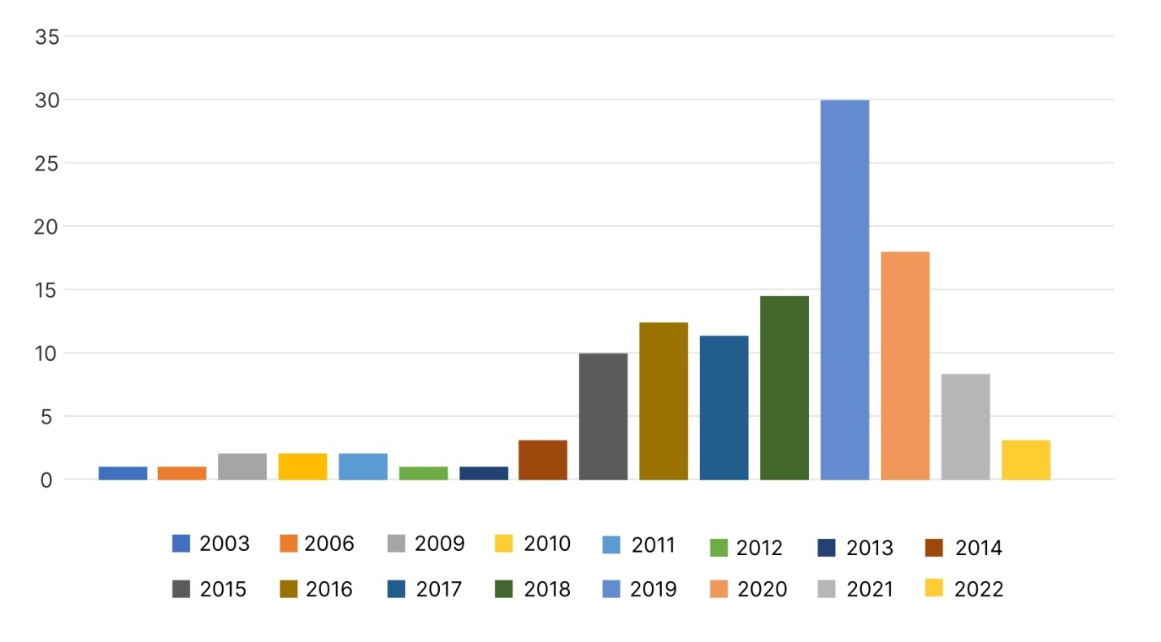
Figure 1.1 The distribution of the considered papers in the period of time between 2003 and 2022.

Upon completing this initial groundwork, we proceeded to the next crucial step, which involved an extensive literature search using a targeted keyword-based strategy. Unlike general literature reviews that often rely on broad search criteria, our methodology focused on refining search parameters to specifically gather relevant experimental research papers. This strategic approach ensured that our study encompassed not only theoretical discussions on malware detection methodologies but also practical implementations and experimental evaluations. By incorporating both theoretical frameworks and empirical findings, we aimed to provide a more holistic and well-rounded assessment of malware detection techniques.
Following the data collection phase, we employed a structured classification framework to systematically organize the selected literature. The classification was carried out based on multiple factors, including but not limited to, malware analysis techniques, different detection approaches, and the specific feature extraction and representation methods utilized in each study. This detailed categorization allowed for a more precise and comprehensive comparison of various methodologies, enabling us to assess their effectiveness across diverse malware detection scenarios. Such a structured organization of information facilitated a deeper understanding of how different techniques perform under varying conditions, ultimately contributing to a more insightful review of the field.
The final stage of our methodology was dedicated to a rigorous and critical evaluation of the selected studies. This phase involved four interconnected processes: reading, understanding, comparing, and systematically analyzing the strengths and weaknesses of each approach. Through this meticulous examination, we were able to extract meaningful insights, recognize key trends shaping the future of malware detection research, and pinpoint significant open research challenges that remain unresolved. The results of this critical evaluation not only informed the conclusions drawn in our survey but also provided a solid foundation for discussing potential future research directions.
To enhance the clarity of our methodological approach, Figure 2 visually represents the sequential steps taken throughout this study. This illustration serves as a graphical depiction of our research workflow, highlighting the logical progression from the initial review of existing studies to the classification and analysis of collected data. By following this structured methodology, we aimed to present a comprehensive and insightful review of malware detection and classification techniques, ultimately contributing to a better understanding of current advancements and ongoing research efforts in this domain.

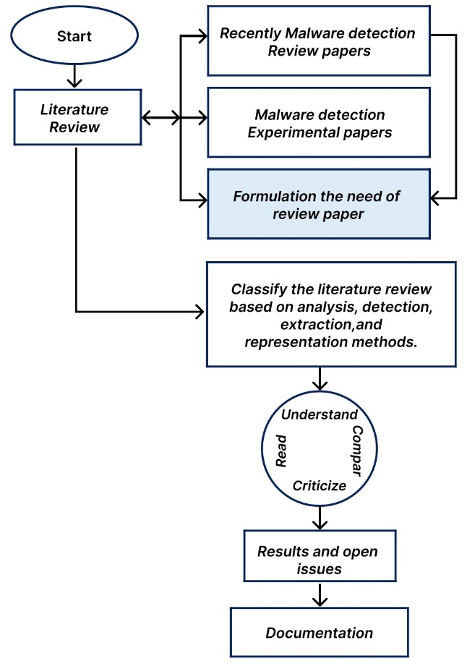

Figure 1.2 Research Methodology.
Several review studies have been conducted in the field of malware detection and classification to define malware types, track their evolution into more sophisticated threats, and analyze obfuscation techniques used to evade detection. Previous research, such as [19,20], categorized malware analysis into static, dynamic, and hybrid approaches while classifying detection methods into signature-based, heuristic-based, specification-based, machine learning-based, deep learning-based, and multimodal-based approaches. Additionally, key challenges faced in malware detection research have been identified, including class imbalance, the need for open and public benchmarks, concept drift, adversarial learning, and the interpretability of detection models. Furthermore, ref. [21] extended these classifications by incorporating sandbox detection as an additional analysis approach.
Feature extraction techniques have also been a focal point in existing literature. The study in [22] classified feature extraction methods into static, dynamic, and hybrid while linking each method to commonly used data types. Additionally, several works [16,17,23,24] explored feature extraction and selection from different perspectives. The study in [23] reviewed machine learning-based malware detection models, categorizing the feature extraction process based on data types. Similarly, [16] classified feature extraction techniques based on employed methodologies, including N-gram, graph-based, and dataset-based approaches. Meanwhile, [17] structured malware analysis by distinguishing between feature extraction steps—such as assembly, representation, and classification—and analysis strategies, including family analysis, similarity analysis, and variant analysis.
The impact of various feature types and classification methods on malware detection performance has also been widely examined, demonstrating that no single approach can effectively detect all malware variants. Ref. [24] presented a comprehensive study on modern feature selection techniques, categorizing them based on theoretical foundations, sparse learning, and statistical methods.
Beyond feature extraction, some researchers have analyzed the evolution of modern malware and its growing complexity. Studies such as [1,9] investigated second-generation malware, highlighting the connection between evolving malware techniques and detection strategies, including signature-based, behavior-based, heuristic-based, specification-based, energy-based, bio-inspired, and machine/deep learning-based methods. The evasive nature of modern malware has been examined in [25], which analyzed the FFRI dataset to determine the prevalence of evasive malware and the evolution of anti-analysis techniques. However, their study focused only on API call-based evasion tactics, leaving out other anti-analysis methods that require further investigation.
Other research efforts have reviewed malware detection techniques tailored to specific threats or attack vectors. For instance, ref. [26] examined malware attacks on smart home networks, classifying them based on smart home architecture, central hubs, and physical security vulnerabilities. The study also addressed VPNFilter malware, discussing its impact on router vendors and smart home network security. Similarly, ref. [27] provided an in-depth analysis of Advanced Persistent Threats (APTs), exploring their characteristics, payload delivery mechanisms, and advanced evasion techniques. Additionally, existing application hardening strategies used to mitigate APTs were categorized, and secure design solutions were proposed.
In the realm of data-driven approaches, ref. [28] surveyed data mining-based malware detection techniques, analyzing how signature-based and behavior-based detection models integrate machine learning algorithms. Their study also quantified the adoption rate of ML algorithms in malware detection research while summarizing key challenges. Likewise, ref. [29] extended this discussion by introducing heuristic-based and specification-based approaches, outlining the advantages and drawbacks of each detection strategy.
Despite the extensive research efforts in malware detection, existing review papers have limitations. Many taxonomies remain at a generic level, focusing only on broad detection categories such as signature-based and behavior-based approaches. In contrast, this study provides a more detailed taxonomy that introduces novel subcategories under each detection approach and systematically links them to the most frequently used data types. By offering a more granular classification, this review enhances the research community’s understanding of malware detection methodologies.
Additionally, while prior review studies predominantly classify feature extraction methodologies based on the broader malware analysis approaches—namely, static, dynamic, and hybrid analysis—our study adopts a fundamentally different perspective. Instead of categorizing feature extraction within the constraints of these analysis phases, we focus on the specific techniques employed for extracting meaningful features from malware data. This nuanced distinction is essential, as it delineates the clear boundary between the initial data collection process, which takes place during malware analysis, and the subsequent feature extraction phase, where relevant characteristics are derived to enhance the detection process. By emphasizing this differentiation, our study provides a more precise and structured understanding of feature extraction methodologies, avoiding the common conflation of these two distinct stages.
Moreover, our survey brings attention to modern and advanced feature extraction techniques that have not been extensively explored in previous literature. Many prior reviews tend to focus on conventional feature extraction methods, often overlooking recent advancements that leverage sophisticated techniques, including deep feature embeddings, graph-based feature representation, and hybrid feature fusion strategies. By incorporating a comparative discussion on the effectiveness of these emerging methodologies, our study offers valuable insights into their impact on improving malware detection accuracy and efficiency. This broader and more contemporary perspective fills a critical gap in the existing body of knowledge, ensuring that researchers and practitioners have access to a more up-to-date and comprehensive evaluation of feature extraction techniques.
Furthermore, this paper introduces a novel taxonomy of feature representation methods, an area that has been largely underexplored in prior reviews. While existing studies often discuss feature extraction in depth, they typically neglect the equally significant aspect of feature representation—how extracted features are structured, transformed, and utilized in malware detection models. Our study systematically defines and categorizes various feature representation strategies, ranging from vectorized and binary representations to more sophisticated approaches such as graph-based embeddings and deep learning-driven feature transformations. By providing a detailed examination of these methods, we enhance the research community’s understanding of how data organization and representation influence the effectiveness of malware detection systems.
Another key contribution of this study lies in its redefinition of machine learning (ML) and deep learning (DL) techniques within the context of malware detection. Unlike traditional reviews that often categorize ML and DL as standalone detection methodologies, we argue that these techniques should instead be viewed as optimization mechanisms that enhance the performance of existing detection strategies. Specifically, rather than treating ML/DL as independent approaches, our study explores how they can be integrated with signature-based, behavioral-based, and heuristic-based detection frameworks to improve classification accuracy, reduce false positives, and enhance generalizability. This perspective provides a more holistic view of ML/DL applications, positioning them as tools for augmenting and refining established malware detection paradigms rather than replacing them outright.
A comparative analysis of this survey and previous review studies is presented in Table 1, highlighting the unique contributions of this study in contrast to earlier works.
Table 1.1 A list of the contributions to this survey with a comparison to the previous review papers.

Review paper | Data | Link data types to Analysis Approaches | Link data types to Detection  Approaches | Detection  Approaches in Deep Categories | Techniques-Based Extraction Methods | Representation Methods | Show the Border between Collection Data and Feature Extraction Phases
[19] | 2018 | ✗ | ✗ | ✗ | ✗ | ✗ | ✗
[20] | 2020 | ✓ | ✗ | ✗ | ✓ | ✓ | ✓
[21] | 2021 | ✗ | ✗ | ✗ | ✗ | ✗ | ✗
[22] | 2014 | ✓ | ✗ | ✗ | ✓ | ✗ | ✗
[23] | 2019 | ✗ | ✗ | ✗ | ✓ | ✗ | ✗
[16] | 2020 | ✓ | ✓ | ✗ | ✓ | ✗ | ✗
[17] | 2021 | ✓ | ✗ | ✗ | ✗ | ✗ | ✗
[24] | 2017 | ✗ | ✗ | ✗ | ✗ | ✗ | ✗
[1] | 2021 | ✗ | ✓ | ✗ | ✗ | ✗ | ✗
[9] | 2020 | ✗ | ✗ | ✗ | ✗ | ✗ | ✗
[25] | 2018 | ✗ | ✗ | ✗ | ✗ | ✗ | ✗
[26] | 2019 | ✗ | ✗ | ✗ | ✗ | ✗ | ✗
[27] | 2019 | ✗ | ✗ | ✗ | ✗ | ✗ | ✗
[28] | 2018 | ✗ | ✓ | ✗ | ✗ | ✗ | ✗
[29] | 2014 | ✗ | ✗ | ✗ | ✗ | ✗ | ✗
This survey | ✓ | ✓ | ✓ | ✓ | ✓ | ✓ | ✓

Сomprehensive taxonomy of malware analysis and detection methodologies. The classification of malware analysis is structured to highlight the relationship between different analysis approaches and the data types they operate on. Meanwhile, malware detection is explored in greater depth by introducing subcategories within each major detection approach, offering a more granular perspective on existing methodologies.
As illustrated in Figure 3, malware analysis techniques are categorized into static, dynamic, and hybrid approaches, along with their most frequently used data types. Each analysis approach is systematically linked to the specific data formats that researchers commonly utilize in malware investigations.
For malware detection, this study extends beyond conventional classification methods by introducing a deeper taxonomy. Instead of limiting the categorization to the well-known signature-based, behavioral-based, and heuristic-based detection techniques, this taxonomy delves into subcategories that define the nuances of each approach.
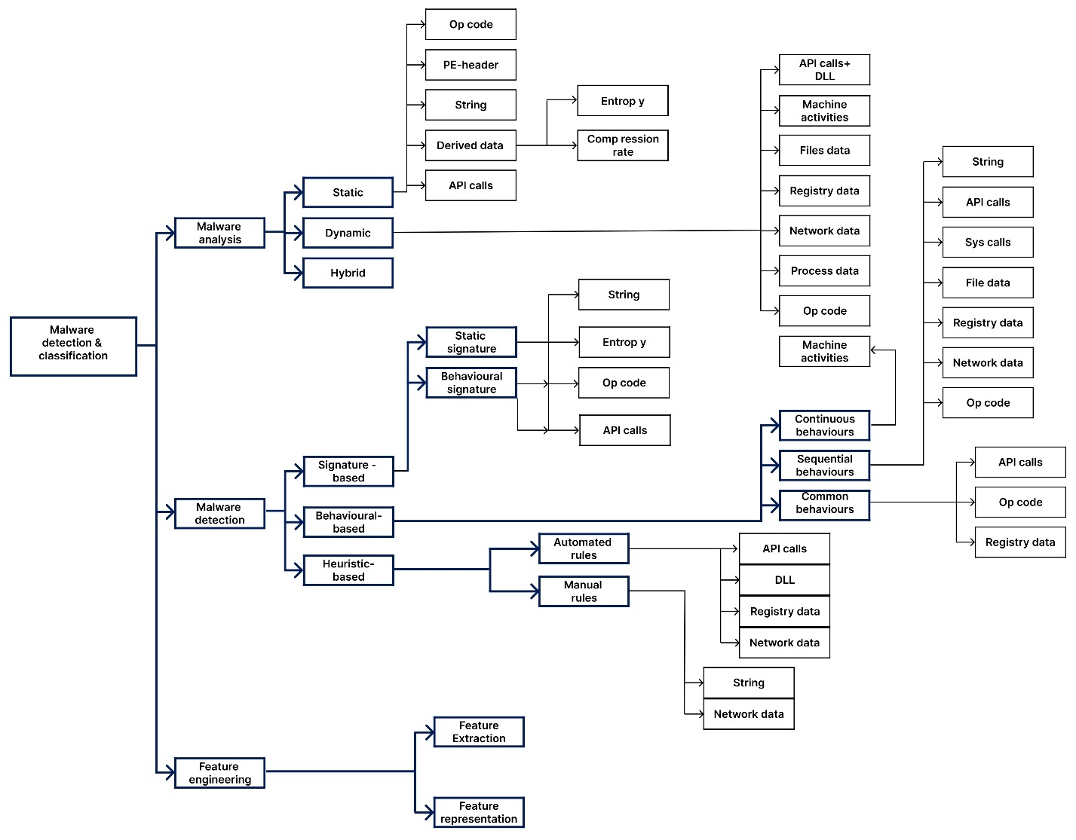
Figure 1.3 Malware Analysis and Detection Taxonomy.
Signature-Based Detection: Divided into static and dynamic signatures, each subcategory is mapped to the relevant data types.
Behavioral-Based Detection: Further classified into continuous, sequential, and common behavioral detection, demonstrating how behavior patterns influence malware classification.
Heuristic-Based Detection: Differentiated into manual and automated rule-based detection, offering insights into how heuristic techniques are implemented in malware identification.
Additionally, each sub-detection approach is systematically associated with the most commonly used data types, enabling a structured understanding of how different techniques leverage data for effective threat detection.
By providing this detailed taxonomy, this study facilitates a more precise understanding of malware detection strategies, helping researchers identify optimal methods for different types of malware and datasets.
Malware analysis plays a crucial role in the detection process by influencing the classification of an examined file, which ultimately affects the overall accuracy of malware detection models. The type of data extracted during analysis significantly impacts the identification of malicious behavior. Various data types—such as Byte code, Opcode, API calls, file system data, registry entries, and network activity logs—are gathered using static, dynamic, and hybrid analysis techniques. These data sources help security researchers understand the functional characteristics of files and classify them as either malicious or benign.
We explore recent studies that have employed different malware analysis approaches, examining the types of data extracted and assessing their impact on detection effectiveness. Table 2 summarizes the characteristics of reviewed studies, categorizing them based on their analysis methodologies and the extracted data types.
Static analysis is a widely adopted technique that examines a program’s source code or binary structure without executing the file. This approach extracts unique identifiers or signatures that characterize the file under investigation. Several types of static data can be obtained, including:
PE-header data: Metadata embedded in Windows executable files, which provides structural details [30,31,32,33].
Derived features: Statistical characteristics, such as string-based entropy, compression ratio, and control flow graphs, which help in malware classification [34,35,36,37].
Opcode and API call sequences: Extracted using disassembly tools like IDA Pro and Python-based analysis frameworks, which aid in understanding program behavior [38,39,40,41,42].
One key advantage of static analysis is its ability to evaluate all possible execution paths without running the code. However, it is highly vulnerable to code obfuscation, packing, and encryption techniques, which can disguise malicious intent and evade detection.
Dynamic analysis, in contrast, involves executing the malware in a controlled, isolated environment, such as a virtual machine (VM) or an emulator, to observe its real-time behavior [43]. This approach helps uncover malicious intent that might not be visible through static analysis. Various types of dynamic data are collected to differentiate between benign and malicious files, including:
API call traces: Monitoring the system functions invoked by the malware during execution [44,45,46,47,48].
Machine activity logs: Capturing system events, process interactions, and memory modifications to detect suspicious behavior [47,49,50].
File system modifications: Tracking changes made to system files, registry entries, and directories [51,52,53].
Network traffic and registry activity: Analyzing data exchanges, including communication with Command-and-Control (C2) servers, to detect network-based threats [45,54].
Opcode-based memory images: Capturing runtime memory snapshots to detect polymorphic and metamorphic malware [15].
Dynamic analysis is effective in bypassing static obfuscation techniques, as malware cannot conceal its behavior while executing. However, it has limitations: it cannot analyze all possible execution paths and is vulnerable to evasion techniques, where malware detects the analysis environment and alters its behavior to avoid detection.
Hybrid analysis combines both static and dynamic approaches to mitigate the weaknesses of each method while enhancing detection accuracy. By integrating static file attributes with runtime behavior patterns, hybrid analysis provides a comprehensive view of malware characteristics.
Tools such as Cuckoo Sandbox, IDA Pro, and OllyDbg are commonly used to extract hybrid datasets [55,56,57,58,59].
Hybrid analysis leverages multiple data types, including opcode sequences, API call logs, file structure metadata, and behavioral signatures, to construct robust detection models.
While hybrid analysis benefits from the strengths of both static and dynamic methods, it also inherits their drawbacks. The computational overhead of running files in a dynamic environment and the vulnerability to advanced evasion tactics remain challenges. Nonetheless, hybrid techniques are increasingly employed in modern malware detection systems to enhance robustness against sophisticated threats.
Figure 4 provides a visual representation of the most commonly used data types across different malware analysis approaches. The x-axis categorizes the various data types employed in malware detection, including:
String-based data (St)
PE-header metadata (P-h)
Opcode sequences (Op)
API call traces (API)
Dynamic Link Library (DLL) references
Machine activity logs (MA)
Process-related data (PD)
File system modifications (FD)
Registry entries (RD)
Network traffic logs (ND)
Derived statistical data (DD), such as entropy and compression ratios
On the y-axis, the three primary malware analysis techniques—static, dynamic, and hybrid analysis—are plotted to illustrate how each data type is utilized in different approaches. The horizontal and vertical dotted lines highlight the frequency of usage of each data type within specific analysis methodologies, providing insights into the relationships between data extraction techniques and malware classification strategies.
This visualization enables researchers to identify trends in malware analysis by showcasing which data types are predominantly used with static, dynamic, and hybrid approaches. Understanding these relationships can help refine detection models, optimize feature selection processes, and develop more resilient malware detection frameworks that leverage a combination of data-driven insights.
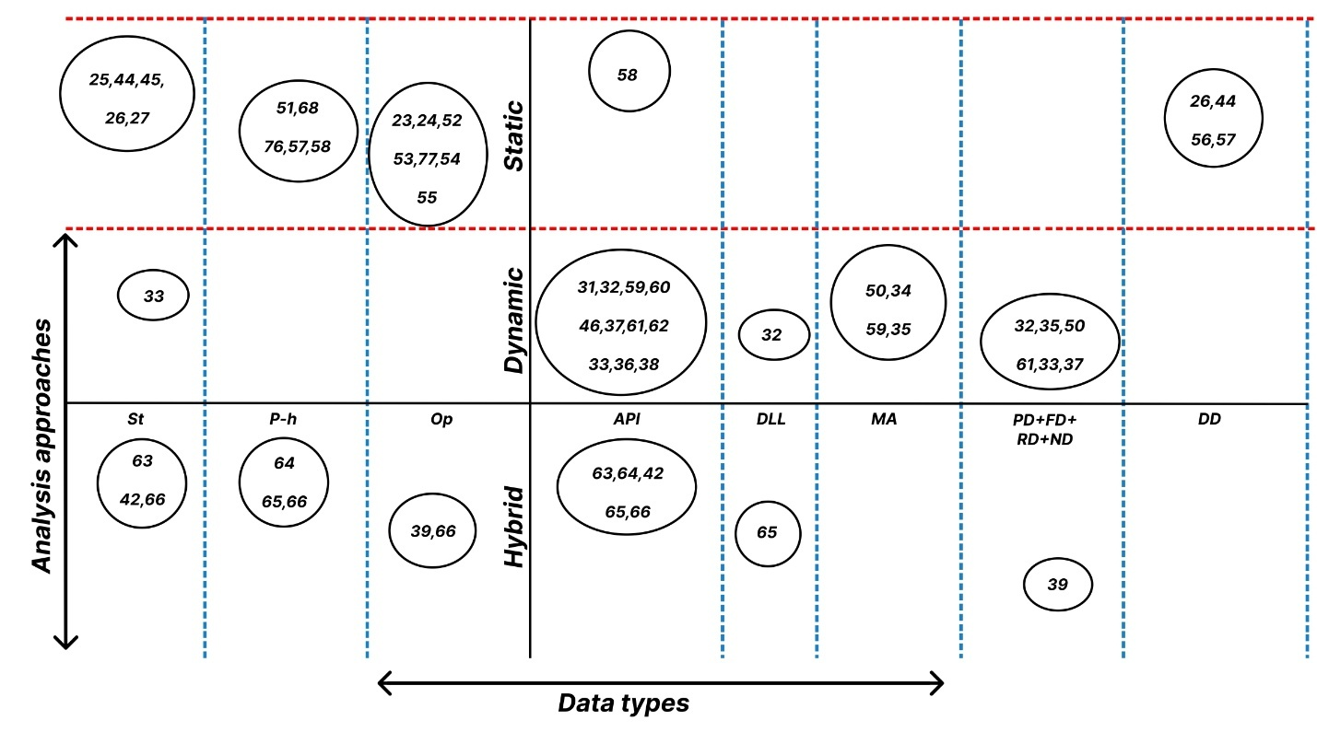
Figure 1.4 Analysis approaches vs. data types.
By analyzing static analysis techniques, it is evident that Opcode and PE-header data are the two most frequently utilized static data types in malware research. This survey also reveals that API calls collected statically are among the least preferred static features, with researchers favoring Byte-code and derived data over static API call traces.
In contrast, dynamic analysis extensively relies on API call data, making it the most significant and frequently used dynamic feature in malware detection. Machine activity logs represent the second most commonly used data type, while registry values, file system interactions, and network traffic data are extracted at an average frequency in dynamic malware analysis studies. However, data types such as Byte-code, PE-header, and Opcode are rarely extracted through dynamic analysis techniques.
For studies employing hybrid analysis, a clear pattern emerges: commonly used static and dynamic data types remain consistent. Opcode, Byte-code, and PE-header continue to dominate static feature extraction, while API calls are the primary data source for dynamic analysis. However, certain dynamic data types—such as file-related data, registry entries, and machine activity logs—are used less frequently in hybrid analysis, indicating a shift in data preferences when integrating both approaches.
Despite its advantages, static analysis faces significant limitations. While it is considered safer because it does not require executing potentially malicious files, malware authors frequently employ packing and encryption techniques—such as UPX and ASPack Shell—to prevent detection. As a result, before static analysis can be performed, malware samples often require unpacking and decompression, which is typically facilitated using disassemblers like IDA Pro and OllyDbg.

On the other hand, dynamic analysis offers a more effective alternative because it eliminates the need to unpack malware before analysis. Additionally, dynamic techniques enhance detection models by identifying novel malware behaviors, making them useful for detecting both known and unknown threats. Another key advantage of dynamic analysis is its resilience against code obfuscation, as obfuscation techniques primarily alter a malware's structural attributes but do not fundamentally change its runtime behavior.
However, dynamic analysis has its own limitations. It is particularly vulnerable to evasive malware, which can detect whether it is being executed in a real or virtualized analysis environment. Advanced evasive techniques enable malware to modify its behavior when running in controlled environments, making detection more challenging. Consequently, while dynamic analysis provides deeper behavioral insights, it requires robust countermeasures to effectively handle malware designed to bypass sandboxed or virtualized execution environments.

1.2 Malware Detection Approaches
The malware detection process is a crucial mechanism designed to identify and classify malicious activities within files under investigation. Over time, various detection techniques have evolved, yet no single approach guarantees complete accuracy against all malware types, families, and variants. Researchers have focused on two primary characteristics of malware for detection: signatures and behaviors. Based on these characteristics, three fundamental malware detection approaches have emerged: signature-based, behavioral-based, and heuristic-based detection.
Signature-based detection has been extensively explored in malware classification research. This method relies on predefined signatures, which are extracted either statically or dynamically, stored in a database, and later compared against the signature of a newly analyzed file. If a match is found, the file is classified as malicious. Common signature components include API call sequences, opcode patterns, byte-code series, and entropy-based characteristics. Various studies have focused on improving signature-based detection models. For instance, string-based signatures were generated in previous research to detect VBasic malware, where extracted strings were represented using frequency vectors. Additionally, n-gram and binary vector-based signatures were introduced to enhance detection accuracy, while opcode-based statistical signatures leveraged opcode frequency distributions to classify malicious files.
Unlike static signatures, behavioral signatures are constructed using dynamically observed patterns. Some studies identified malicious API call sequences invoked during execution, utilizing these runtime interactions to build behavioral signatures. Specific sets of API calls were recognized as strong indicators of malicious activity, allowing researchers to develop behavior-based detection models based on execution traces. While signature-based detection is efficient for detecting known malware, it has significant limitations. It struggles to identify new or unknown malware strains, as it relies on an existing signature database. Malware variants can modify their signatures through obfuscation, encryption, or polymorphic techniques, making them harder to detect. Additionally, signature-based methods have low detection rates against zero-day threats, where no prior signature exists.
To overcome the shortcomings of signature-based techniques, researchers have explored behavioral-based and heuristic-based detection methods. These approaches focus on analyzing malware behavior rather than relying on static signatures, making them more adaptable to new and evolving threats. By continuously refining detection models and incorporating advanced analysis techniques, researchers aim to enhance the effectiveness of malware detection systems in combating modern cyber threats.
Behavioral-based malware detection relies on monitoring executable files in an isolated environment and analyzing their exhibited behaviors. Feature extraction techniques are then applied to identify sensitive behavioral patterns, enabling detection models to classify known malicious activities while also recognizing similar behaviors that could indicate new malware. Unlike signature-based detection, which relies on pre-existing identifiers, behavioral-based detection can detect novel threats by observing their runtime activities, making it a more effective approach for modern malware detection. As a result, a significant portion of recent studies has focused on leveraging behavioral-based approaches, categorizing malware behaviors into continuous, sequential, and common behaviors to improve detection accuracy.
Several studies have investigated continuous behaviors, often represented by machine activities. One such study focused on malware affecting the Windows platform and utilized the Cuckoo sandbox to extract machine activity data, including CPU usage, memory consumption, and network traffic patterns. These observations were then transformed into feature vectors to train and evaluate classification models. Other research efforts concentrated on extracting API calls, system calls, and opcode sequences to construct sequential behavioral patterns. Ordered patterns derived from API calls, registry modifications, and network activity have been used to gain deeper insights into malware functionality. Some studies explored the use of opcode sequences for a more fine-grained analysis of malware operations. Additionally, researchers have identified common behaviors shared among malware families, which can serve as reliable indicators for classification. These common behaviors are particularly useful in binary classification models for distinguishing malware from benign files and in multi-classification models for differentiating between various malware families. Graph-based models have also been proposed, where frequently observed behavior graphs were used to classify malware families. Another study utilized long short-term memory (LSTM) networks to develop both binary and multi-class classification models based on common API call sequences within malware families.
Heuristic-based detection is another widely used approach that relies on the generation of generalized rules to analyze extracted data obtained through static or dynamic analysis. These rules support the detection models by identifying patterns indicative of malicious intent. Heuristic rules can be developed automatically using machine learning techniques, specialized tools such as YARA, or manually by cybersecurity experts with extensive knowledge of malware behaviors. Some studies focused on building malware detection models that relied on automated behavioral rules generated through machine learning and YARA-based frameworks. Other research efforts aimed at static analysis explored the use of manually defined rules based on extracted string data to identify malicious activities, particularly in malware that leverages HTML elements and JavaScript functions.
Additionally, researchers have proposed domain name system (DNS)-based rules to detect botnet attacks by analyzing abnormalities in DNS queries and responses. These manually crafted rules played a critical role in the final classification decision.
The effectiveness of different malware detection approaches varies based on the type of data used and the evasion techniques employed by malware developers. According to the literature, researchers have utilized string, opcode, and derived features to construct static signatures, while API calls and opcode sequences have been the primary components of dynamic signatures. However, relying solely on predefined signatures for detection has proven insufficient due to obfuscation techniques that allow malware authors to generate new variants that bypass traditional signature-based defenses. Each malware variant exhibits a unique fingerprint that must be identified before it can be effectively detected.
To address these challenges, hybrid detection techniques combining static and dynamic analysis have gained attention, as they leverage the strengths of both approaches. Machine learning-based models have also emerged as a promising solution, enabling adaptive detection mechanisms that can identify previously unseen malware variants. However, these models require extensive training on diverse datasets to achieve high accuracy and generalization. Moreover, malware developers continue to refine evasion tactics, necessitating continuous updates and improvements in detection frameworks to maintain their effectiveness .Behavioral-based detection offers a promising alternative by analyzing malware functionality rather than relying on static patterns. Among the various data types used in behavioral analysis, machine activity data has been the most widely used for modeling continuous behaviors, while API call sequences have been the most frequently employed for constructing sequential behavior-based models. Additionally, API call logs and opcode sequences have been the most commonly used data types for identifying common behaviors among malware families. These techniques allow for a more dynamic understanding of malware operations, enabling security systems to detect previously unknown threats more effectively.
While behavioral-based detection improves malware classification accuracy, it is not without limitations. One significant challenge is the high false-positive rate caused by malware that mimics legitimate behavior or performs functions similar to benign software. Furthermore, evasive malware can detect when it is being executed in a controlled analysis environment and modify its behavior to appear non-malicious or even terminate execution to evade detection. This makes it crucial to develop more robust behavioral analysis frameworks capable of identifying subtle anomalies in execution patterns.
Table 1.2 The relation between analysis approaches and data types.

Ref. | Data | String | PE- Header | Opcode | API calls | DLL | Machine Activities | Process  data | File  data | Register  data | Network  data | Entropy | Compression | Accuracy
Static Analysis
[38] | 2015 |  |  | ✓ |  |  |  |  |  |  |  |  |  | 98.60%
[31] | 2015 |  | ✓ |  |  |  |  |  |  |  |  |  |  | 99.97%
[64] | 2016 | ✓ |  |  |  |  |  |  |  |  |  |  |  | 90.00%
[35] | 2018 | ✓ |  |  |  |  |  |  |  |  |  | ✓ |  | NA
[39] | 2017 |  |  | ✓ |  |  |  |  |  |  |  |  |  | 96.09%
[65] | 2017 |  |  | ✓ |  |  |  |  |  |  |  |  |  | 98.90%
[61] | 2017 | ✓ |  |  |  |  |  |  |  |  |  |  |  | 81.07%
[41] | 2018 |  |  | ✓ |  |  |  |  |  |  |  |  |  | NA
[32] | 2019 |  | ✓ |  |  |  |  |  |  |  |  |  |  | 99.80%
[33] | 2019 |  | ✓ |  |  |  |  |  |  |  |  |  |  | 87.50%
[42] | 2019 |  |  | ✓ |  |  |  |  |  |  |  |  |  | 97.87%
[66] | 2020 |  |  | ✓ |  |  |  |  |  |  |  |  |  | NA
[67] | 2019 |  |  | ✓ |  |  |  |  |  |  |  |  |  | 91.43%
[34] | 2016 | ✓ |  |  |  |  |  |  |  |  |  |  | ✓ | 89.44%
[36] | 2019 |  |  |  |  |  |  |  |  |  |  | ✓ |  | NA
[37] | 2019 |  |  |  |  |  |  |  |  |  |  | ✓ |  | NA
[40] | 2020 |  |  | ✓ | ✓ |  |  |  |  |  |  | ✓ |  | NA
[68] | 2016 |  | ✓ |  | ✓ |  |  |  |  |  |  |  |  | 98.17%
Dynamic analysis
[43] | 2015 |  |  |  |  |  |  | ✓ |  |  |  |  |  | 97.8%
[44] | 2016 |  |  |  | ✓ |  |  |  |  |  |  |  |  | 97.19%
[15] | 2016 |  |  | ✓ |  |  |  |  |  |  |  |  |  | 98.92%
[45] | 2016 |  |  |  | ✓ | ✓ |  |  |  | ✓ |  |  |  | 96.00%
[52] | 2016 |  |  |  |  |  | ✓ |  | ✓ |  |  |  |  | NA
[69] | 2017 |  |  |  |  |  | ✓ |  |  |  |  |  |  | 98.54%
[47] | 2018 |  |  |  | ✓ |  | ✓ |  |  |  |  |  |  | NA
[49] | 2019 |  |  |  |  |  | ✓ |  |  |  |  |  |  | 92.00%
[54] | 2019 |  |  |  | ✓ |  |  |  |  |  | ✓ |  |  | 97.22%
[48] | 2019 |  |  |  | ✓ |  |  |  |  |  |  |  |  | 94.89%
[46] | 2020 |  |  |  | ✓ |  |  |  |  |  |  |  |  | 97.28%
[53] | 2019 |  |  |  | ✓ |  |  |  | ✓ |  |  |  |  | 75.01%
[70] | 2020 |  |  |  | ✓ |  |  |  |  |  |  |  |  | 98.43%
[51] | 2020 | ✓ |  |  | ✓ |  |  |  | ✓ | ✓ | ✓ |  |  | 99.54%
[71] | 2017 |  |  |  | ✓ |  |  |  |  |  |  |  |  | NA
Hybrid analysis
[72] | 2014 | ✓ |  |  | ✓ |  |  |  |  |  |  |  |  | 98.71%
[55] | 2016 |  |  | ✓ |  |  |  |  | ✓ |  |  |  |  | 99.99%
[73] | 2019 |  | ✓ |  | ✓ |  |  |  |  |  |  |  |  | 99.70%
[58] | 2021 | ✓ |  |  | ✓ |  |  |  |  |  |  |  |  | 94.70%
[74] | 2020 |  | ✓ |  | ✓ | ✓ |  |  |  |  |  |  |  | 93.92%
[75] | 2020 | ✓ | ✓ | ✓ | ✓ |  |  |  |  |  |  |  |  | 96.30%

Extracting a comprehensive set of behavioral features remains a challenging task, as feature selection has a direct impact on the accuracy of detection models. Additionally, the computational overhead associated with real-time behavioral monitoring can be substantial, limiting its practicality in resource-constrained environments.
Another challenge associated with behavioral-based detection is its vulnerability to obfuscation techniques that manipulate the names, sequence, or frequency of extracted features.
Many researchers have attempted to counteract these challenges by training their models on recent malware samples to improve their ability to recognize emerging threats. However, this approach makes the detection models less effective against older malware strains, which may still pose a risk.
In the case of heuristic-based detection, no single data type dominates its implementation, as researchers have employed a diverse range of features, including API calls, network traffic data, registry modifications, imported DLL files, and other system-level interactions. One of the key challenges of heuristic-based detection is the requirement for manually generated investigation rules, which demand significant time and expertise from cybersecurity analysts. Although heuristic rules can be generated automatically using machine learning, the resulting models are still limited to detecting only the malicious activities explicitly represented in the predefined rules. This constraint makes heuristic-based models susceptible to false negatives, as they may fail to detect malware that exhibits novel attack patterns beyond the scope of the predefined rules.
Overall, the evolution of malware detection techniques highlights the need for more adaptable and intelligent approaches that can effectively counter emerging threats. While static and behavioral-based detection methods each have their strengths and weaknesses, integrating multiple techniques and leveraging advanced machine learning frameworks may provide a more robust and resilient solution against modern cyber threats.
Comprehensive taxonomy of feature extraction and representation methods, addressing key distinctions between data collection, extraction, and representation phases. Unlike previous taxonomies, which primarily categorized feature extraction based on analysis approaches (static, dynamic, or hybrid), this study introduces a more technique-driven classification of feature extraction methods. By focusing on the techniques used to extract features rather than the analysis method, this taxonomy provides a clearer perspective on how features are derived, processed, and utilized in malware detection models.
In addition to refining the classification of feature extraction techniques, this study introduces a novel taxonomy for feature representation methods. This addition aims to clearly distinguish between the various stages of data processing, from raw data collection during malware analysis to feature extraction, where relevant attributes are derived, and finally, feature representation, where the extracted features are structured for use in classification models. These distinctions are critical for improving the accuracy and efficiency of malware detection frameworks.
The proposed feature extraction and representation taxonomy is visually depicted in Figure 5, illustrating the different methodologies employed in extracting and structuring features for malware classification. By offering a more granular and structured approach, this taxonomy enhances researchers' understanding of the relationships between data processing techniques and their impact on malware detection performance.
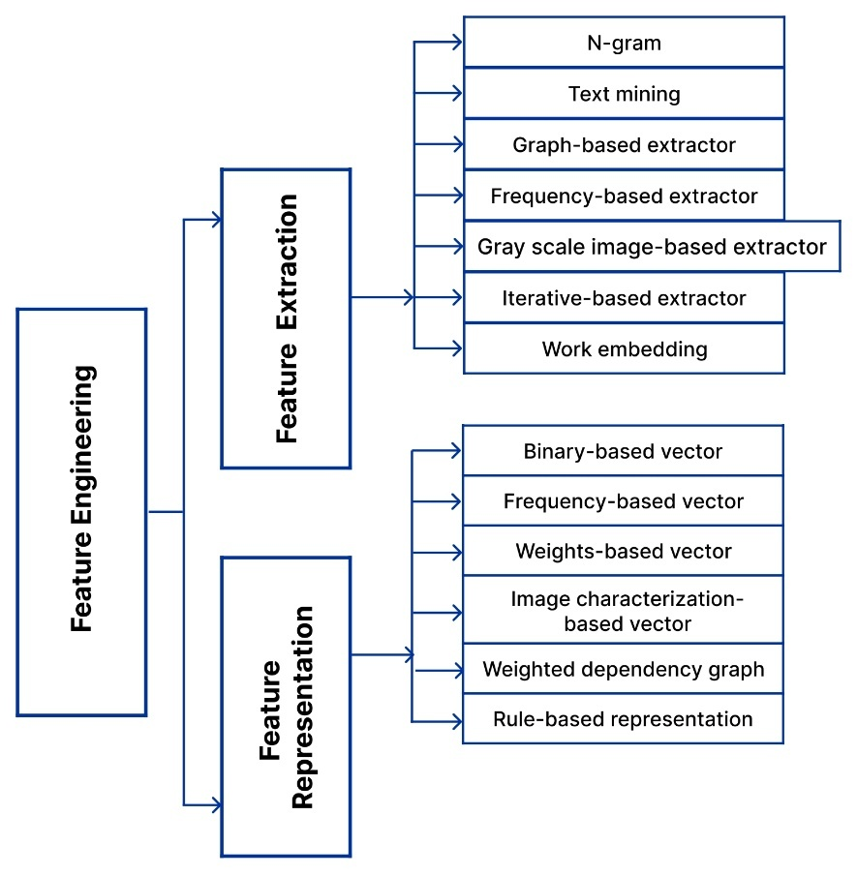
Figure 1.3 Taxonomy of feature extraction and representation methods.
Feature engineering plays a crucial role in the malware detection and classification process, encompassing the extraction, selection, and representation of relevant features. The efficiency and accuracy of a classification model are significantly influenced by the quality of feature engineering, as it structures data into a format that is more comprehensible for machine learning algorithms [70]. Additionally, by refining and reducing the dataset, feature engineering helps minimize computational overhead, leading to more efficient processing and faster malware detection [22,79]. This section explores different feature extraction techniques based on the methods used to derive features from raw malware data. Table 3 presents a summary of feature extraction methods employed in various reviewed studies.
Extracting individual features, such as API calls or opcode sequences, in isolation often results in lower detection accuracy, as it disregards the significance of sequential feature relationships within malware behavior patterns. Malware does not rely on a single isolated feature for execution; instead, its activities often depend on combinations of API calls, opcode sequences, or system interactions. To capture these relationships, malware detection models have widely adopted n-gram-based feature extraction techniques to aggregate multiple features into structured sequences that better reflect malicious intent.
The n-gram technique involves constructing features based on N consecutive elements, where each extracted feature is formed from a sequence of N features observed during malware execution. This method enhances the ability to recognize patterns in malware behavior, improving classification accuracy. Several studies have demonstrated the effectiveness of n-gram-based feature extraction in malware detection [50,65,72,80,81].
In text classification, n-grams are constructed by dividing a given text into fixed-length substrings. Depending on the application, these substrings may consist of characters, words, opcode sequences, API call chains, or binary representations. The use of n-gram feature extraction enhances similarity measurements by identifying recurring patterns within malware datasets, allowing models to detect malware families with similar behavioral traits [82].
However, the primary challenge associated with n-gram-based feature extraction is its high-dimensional feature space. Since a large number of n-gram features are generated, models must process highly complex and voluminous datasets, leading to increased computational costs and longer processing times [10]. Therefore, dimensionality reduction techniques such as feature selection and embedding methods are often employed to optimize the performance of malware detection models while maintaining high classification accuracy.
Text mining techniques, originally derived from the field of information retrieval, play a crucial role in feature extraction for malware detection. These techniques are generally categorized into term indexing and term weighting. Term indexing assigns a unique identifier to each extracted term, while term weighting calculates and assigns a specific importance score to each term. In the context of malware detection and classification, term weighting has been widely used to extract significant features, ensuring that highly relevant terms are prioritized to enhance the performance of classification models.
Several techniques, such as Term Frequency-Inverse Document Frequency (TF-IDF) and Information Gain (IG), are commonly used for text mining in malware analysis. These methods help determine the relative importance of extracted terms, enabling analysts to identify the most useful features for classification. One study employed Information Gain to assign weights to analysis report texts, where these weights reflected the significance of performed operations and their locations in malware and benign files. Another study utilized TF-IDF to evaluate API call sequences and network traffic, assessing the frequency of specific features in malware and benign datasets to identify highly informative and uncommon indicators of malicious behavior. By applying text mining techniques, researchers can effectively extract structured feature representations from unstructured malware reports, improving detection accuracy.
Graph-based feature extraction techniques focus on structuring raw malware data, such as API calls and opcode sequences, into graph representations that illustrate the appearance frequency and relationships between different features. These relationships help identify frequent sub-graphs, which can serve as distinguishing characteristics for malware classification.
In this approach, malware samples are transformed into graph structures, where:
Nodes represent individual features (e.g., API calls, opcodes, or function names).
Edges define dependencies, control flows, or execution sequences between the nodes.
Table 1.2 Summary of detection approaches, extraction, and representation methods.

Referance | Feature Engineering |  | Model Type |  | Technique | Model Mode |  | Detection Approach
 | Feature Extraction | Feature Representation | Binary-  Class | Multi-  Class |  | General | Specific | Signature-based | Behavioral-Based | Heuristic-Based
[43] | Text mining | Weight-based vector | ✓ |  |  | ✓ |  | ✓
[72] | Frequency-based extractor, N-gram | Binary-based vector | ✓ |  | SVM |  | ✓ |  | ✓
[45] | Frequency-based extractor | Binary-based vector | ✓ |  | SVM | ✓ |  |  |  | ✓
[34] | Frequency-based extractor | Weight-based vector | ✓ |  | AMA |  | ✓ |  |  | ✓
[39] | Graph-based extractor | Weight-based vector |  |  | K-NN,SVM
[35] | Frequency-based extractor | Frequency-based vector | ✓ |  | RF |  | ✓ | ✓
[83] | N-gram | Binary-based vector |  | ✓ | K-NN | ✓ |  |  | ✓
[80] | Graph-based extractor | Weighted dependency graph | ✓ |  |  | ✓ |  |  | ✓
[84] | Iterative-based extractor | Weight-based vector |  | ✓ | J48,K-NN |  | ✓ |  | ✓
[54] | Test mining | Rule-based representation | ✓ |  |  | ✓ |  |  |  | ✓
[63] | Frequency-based extractor | Binary -based vector | ✓ |  | SVM | ✓ |  | ✓
[75] | N-gram, Frequency-based extractor, Gray-scale image-based extractor | Image characterization based vector | ✓ | ✓ | XGBoost | ✓ |  |  | ✓
[74] | N-gram | Weight – based vector | ✓ |  | RF | ✓ |  |  | ✓
[85] | Word embedding | Weight – based vector | ✓ |  | MC | ✓ |  |  | ✓
[50] | N-gram | Frequency-based vector | ✓ |  | SVM | ✓ |  |  | ✓
[10] | Graph-based extractor | Binary-based vector | ✓ |  | HLES-MMI |  | ✓ |  | ✓
[81] | N-gram | Weight – based vector | ✓ |  |  | ✓ |  | ✓
[70] | N-gram | Binary -based vector | ✓ |  | LR | ✓ |  |  | ✓
[86] | Gray-scale image-based extractor | Image characterization based vector | ✓ |  | SVM,CNN | ✓ |  |  | ✓
[40] | N-gram,Frequency-based extractor | Frequency-based vector, weight vector | ✓ |  | XGBoost | ✓ |  | ✓
[87] | N-gram,Frequency-based extractor | Frequency-based vector | ✓ |  | CNN,BPNN | ✓ |  |  | ✓
[88] | Word embedding | Weight – based vector | ✓ |  | RNN | ✓ |  |  | ✓
[89] | Frequency-based extractor | Weight – based vector | ✓ |  | CS | ✓ |  |  | ✓
[90] | Frequency-based extractor | Binary -based vector | ✓ |  | SVM | ✓ |  |  | ✓
[91] | Graph-based extractor | Weight-based vector | ✓ | ✓ |  | ✓ |  |  | ✓
[76] | Frequency-based extractor | Rule-based representation | ✓ |  |  | ✓ | ✓ |  |  | ✓
[92] | Frequency-based extractor | Weight -based vector | ✓ |  | JSD | ✓ |  |  | ✓
[93] | Gray-sxcale image -based extractor | Image characterization based vector |  | ✓ | CNN | ✓ |  | ✓
[94] | Gray-sxcale image -based extractor | Image characterization based vector |  | ✓ | SVM | ✓ |  | ✓

Frequent sub-graphs that appear in multiple malware samples are identified as significant features for classification. Several studies have constructed Control Flow Graphs (CFGs) based on API call sequences and opcode dependencies to differentiate between malware and benign files. Some models apply matching algorithms to compare constructed graphs directly, while others convert the graphs into binary vectors, weighted dependency graphs, or adjacency matrices for classification.
Despite the advantages of capturing complex relationships between features, graph-based methods introduce computational overhead. Constructing unique graphs for each malware sample is challenging, and relying solely on common sub-graph behaviors can lead to longer processing times in large-scale datasets.
In malware detection, not all extracted features contribute equally to classification. Some features provide high discriminative power, while others are redundant or irrelevant. Frequency-based feature extraction methods measure feature occurrence rates in malware and benign datasets, identifying high-frequency features that are strong indicators of malware behavior.
The fundamental principle behind frequency-based extraction is that features appearing frequently in malware samples but rarely in benign samples are likely to be malicious indicators. This method prevents the creation of extremely high-dimensional feature spaces, improving efficiency. Several studies have applied frequency-based feature extraction to construct datasets of API calls, opcode sequences, DLL imports, and registry modifications. Some researchers have measured API call frequency distributions, while others focused on DLL usage patterns and registry key occurrences.
However, obfuscation techniques such as instruction replacement and dead code insertion can alter feature occurrence patterns, impacting the effectiveness of frequency-based models. Attackers can manipulate feature frequencies to evade detection, necessitating additional techniques like feature selection or deep learning embeddings to maintain detection accuracy.
Word embedding techniques, originally developed for natural language processing (NLP), have been adapted for malware detection to capture the semantic relationships between extracted features. Word2Vec, one of the most widely used embedding techniques, offers two primary architectures:

Continuous Bag of Words (CBOW) – Predicts a target word based on its surrounding context words.
Skip-Gram – Predicts context words based on a given target word.
Word2Vec transforms a corpus of text into vector space representations, where each feature (e.g., API call or opcode) is represented as a numerical vector. Features with similar contextual usage are placed closer together in vector space, allowing malware classifiers to understand semantic relationships between API calls and opcode sequences.
Several studies have employed Word2Vec-based embeddings to model API call sequences and opcode dependencies. Some researchers generated vectorized feature representations of API sequences to enhance malware classification, while others applied Skip-Gram models to map opcode relationships.
Although Word2Vec techniques capture contextual relationships effectively, they introduce high computational complexity. Training high-dimensional embeddings requires substantial processing power, and the resulting feature representations may introduce unnecessary complexity, potentially reducing the overall efficiency of detection models. To mitigate this, some researchers combine Word2Vec embeddings with dimensionality reduction techniques, such as Principal Component Analysis (PCA) or t-SNE, to optimize classification performance.
The primary objective of any malware detection and classification model is to achieve high accuracy in classifying test data. The iterative-based feature extraction method focuses on identifying the features that contribute most significantly to improving detection accuracy. One of the main challenges in this approach is determining the initial feature set. A practical solution to this challenge is to include all features that frequently appear in samples of a particular class and then refine the selection through multiple iterations. This method involves conducting a series of experiments, analyzing the results, and systematically adding or removing specific features to optimize the feature set for the highest performance.
In previous studies, researchers extracted a core feature set from malware analysis reports by iteratively testing different feature combinations and observing their impact on classification accuracy. While this method ensures that only the most effective features are included, it is highly time-consuming and resource-intensive, requiring extensive computational effort to fine-tune the feature set.
An innovative malware detection technique involves converting malware binaries into images and extracting visual features for classification. In this approach, malware binary files are divided into 8-bit units, where each unit corresponds to a pixel in an image. Since 8-bit values range from 0 to 255, this allows malware to be visualized in gray-scale format, where 0 represents black, 255 represents white, and values in between represent different shades of gray. By analyzing these images, researchers can extract visual patterns, such as texture, intensity, and wavelet features, to distinguish between malware and benign files.
Malware families often reuse code, which leads to similar visual patterns in gray-scale images. Some studies have used machine learning techniques to classify malware based on extracted image features, while others have employed transfer learning-based convolutional neural networks (CNNs) to improve detection performance. One study converted malware binaries into 1D, 8-bit vectors, transformed them into 2D images, and then applied CNN-based classification models such as VGG16. The best performance was achieved using transfer learning techniques, where pre-trained deep learning models were adapted to extract malware-specific features.
While gray-scale image-based detection offers a novel approach, it has some limitations. The storage requirements for image-based datasets are significantly higher than for traditional feature representations. Additionally, classification models require a large number of malware families during training to generalize well, making them less effective in detecting rare or newly emerging malware variants.
While n-gram feature extraction is widely used due to its ability to capture sequential dependencies, it introduces high-dimensional feature spaces, which increase computational complexity. To counter this, frequency-based feature extraction selects only high-frequency features, reducing dimensionality. However, obfuscation techniques can manipulate feature frequencies, making frequency-based models less reliable.
Graph-based feature extraction provides a structured representation of malware behaviors but suffers from complexity issues, particularly during graph matching. Some researchers have attempted to mitigate this by vectorizing graphs, making them easier to process.
Text mining-based approaches, such as TF-IDF, assign weights to text features to improve feature selection. However, these models remain vulnerable to obfuscation, as attackers can modify text-based feature distributions to evade detection.
The gray-scale image-based approach enables visual pattern analysis of malware binaries but requires high storage capacity and large labeled datasets for training. Meanwhile, word embedding techniques, such as Word2Vec, enhance the contextual understanding of malware features but introduce computational overhead that can impact detection efficiency.
Each feature extraction method has strengths and weaknesses, making it essential to select an appropriate method based on the specific goals of the malware detection model. Future advancements in automated feature engineering and deep learning-driven extraction techniques may further enhance malware classification accuracy.
After extracting relevant features, the next critical step in malware detection is feature representation, which involves converting raw features into a structured format that machine learning algorithms can process. The way features are represented significantly influences the effectiveness of malware classification models. Various vector-based representation methods have been employed to help models learn and distinguish between malicious and benign behaviors [79].
This section categorizes and discusses different feature representation methods, as summarized in Table 3.
Binary vector representation examines extracted features from a boolean perspective, where features are assigned values of 1 (true) if they are present in a sample and 0 (false) if they are absent. This method creates a binary feature vector, which represents whether specific malware-related characteristics exist in a given file.
Some studies have integrated static printable string features and dynamic API n-gram features into hybrid binary vectors, enabling models to capture both static and dynamic malware characteristics. Another study converted API call sequences into binary vectors, where each API call was represented by 1 or 0 based on its presence in a predefined global list.
Despite its simplicity, binary vector representation has significant vulnerabilities. Obfuscation techniques can introduce irrelevant features, such as redundant API calls or unused opcode sequences, to mislead detection models. Additionally, malware authors can inject legitimate-looking features to disguise malicious intent, causing binary-based models to misclassify malware as benign software.
As malware authors frequently reuse existing malicious code to create new variants, frequency-based feature representation is widely used to detect malware families. In this method, extracted features such as API calls, opcodes, or function names are represented by their occurrence frequency within a sample.
Studies have used frequency-based representation to identify malware by analyzing differences in the frequency of performed functions between malware and benign programs. Some researchers focused on VBasic-based malware, extracting specific functions, methods, and keywords, while others used API call frequency to construct feature vectors.
Despite its effectiveness, frequency-based representation is vulnerable to obfuscation techniques, such as dead code insertion, which artificially alters feature distributions to evade detection.
Weight-based representation assigns numerical values to extracted features based on their importance in malware classification. This approach is commonly implemented using statistical methods such as Term Frequency-Inverse Document Frequency (TF-IDF), Information Gain (IG), and entropy-based weighting.
In this method, features frequently associated with malware samples receive higher weights, while those appearing in both malware and benign files receive lower weights. One study calculated normalized frequency values for extracted words, using Information Gain to assign weights for classification. Another study employed TF-IDF to select significant features and represented them as weighted vectors in an Attribute Relation File Format (ARFF).
However, weight-based representation does not capture contextual relationships between features, which can limit classification performance in certain models.
In gray-scale malware detection, malware binaries are converted into images, and image processing techniques are applied to generate feature vectors. These images are characterized by texture, intensity, and color distribution, which differ between malware and benign files.
Several algorithms, such as Color Layout Descriptor (CLD), Homogeneous Texture Descriptor (HTD), and GIST, are used to extract numerical vectors that represent malware images. However, this method requires large storage capacity and suffers from misclassification issues when training data lacks sufficient malware variants.
Since malware can obfuscate individual feature sequences, dependency-based methods have been introduced to capture feature relationships. Weighted dependency graphs express the probability of dependencies between extracted features, making models more resilient to instruction reordering and feature injection.
Some studies have employed Maximum Weight Subgraph Algorithms (MWSA) and NP-similarity measures to analyze dependency graphs, setting thresholds to classify malware behaviors.
Rule-based feature representation models malware behavior through manually or automatically defined rules. Tools like YARA generate automated rules, while cybersecurity analysts manually construct rule sets.
Although effective in some cases, rule-based models are limited to detecting only the malicious activities explicitly defined in their rules, making them less adaptable to evolving malware threats.

CHAPTER 2. ADVANCED MALWARE DETECTION TECHNIQUES

2.1 Machine Learning and Deep Learning-Based Malware Detection
With the increasing prevalence of malware, the demand for effective detection technologies has become more urgent. A recent report [1] indicates that by 2023, the total number of malware and potentially unwanted applications (PUAs) has surpassed 1.2 million, with malware accounting for over 80% of this figure. In the past few years, the frequency of malware attacks has surged [2], with more than 300,000 new malware instances emerging daily—equating to approximately 3.5 new malware samples per second. The impact of malware is severe, leading to privacy breaches, data leaks, system crashes, and data corruption. As a result, developing a more automated and robust malware detection system is essential.
Several studies have explored machine-learning and deep-learning techniques for detecting malicious code. Huang et al. proposed a hybrid malware visualization method that integrates static and dynamic analysis [3]. They utilized the Cuckoo sandbox to conduct dynamic analysis and converted the results into images, which were then used to train deep-learning models. Their approach achieved accuracy rates of 82.5% and 92.5%, respectively, across two different models. While deep-learning algorithms offer significant advantages in image classification by automatically learning texture-based features, directly extracting features from raw malware files can overlook critical behavioral characteristics, making it challenging to capture key features. To address this, Shenderovitz et al. introduced Bon-APT, an approach that segments API call sequences during dynamic analysis to examine Advanced Persistent Threat (APT) behavior. Their model, tested on a large dataset, demonstrated high accuracy in both APT detection and attribution [4].
Despite these advancements, existing malware detection techniques remain limited. Many visualization-based approaches transform binary code into images without fully considering the structural and semantic relationships within the code. Meanwhile, API call sequence-based models primarily focus on extracting API patterns without integrating broader statistical features. For instance, Li et al. [5] developed a method to extract semantic information from API call sequences, analyzing behavioral details, operational targets, and functional goals. Using deep-learning models, they integrated these features for classification, achieving an accuracy of 97.31%. However, their approach only focused on sequence features while ignoring statistical features, such as the frequency of specific API calls and their interdependencies—elements that can significantly impact detection performance.
Similarly, visualization-based techniques have shown promising results but also face limitations. Vasan et al. [6] proposed the IMCFN model, which converts malware binaries into RGB images before feeding them into a classification model, achieving an accuracy of 98.82%. However, this approach relies solely on direct sequence-based modeling, which may lead to information loss concerning malware structure and behavior. Converting raw code into images without considering instructional relationships or API interactions can limit the model’s generalization ability across diverse malware families.
To address these challenges, this paper proposes a malicious code detection method that combines deep learning with API call sequence analysis. Our method leverages deep-learning techniques to comprehensively extract meaningful patterns from API call sequences, converting them into images to enhance detection capabilities. By representing API sequences as images, we can extract macro-level sequence features, while simultaneously using text-based sequence features as a supplement. This hybrid approach overcomes the limitations of single-feature extraction techniques by expanding the feature space and improving classifier expressiveness.
A key enhancement of our proposed model is an optimized grayscale image mapping strategy, ensuring a more uniform pixel-value distribution in the final representation. This refinement allows convolutional neural networks (CNNs) to better capture distinct malware features, leading to improved classification accuracy. Additionally, by analyzing API interactions, our method provides a detailed insight into software behavior, identifying malicious patterns that traditional detection models may overlook.
From a privacy and security perspective, our approach ensures minimal data collection while maintaining high detection efficacy. Specifically, our system only logs API call sequences—it does not collect API parameters or any other sensitive user data. Malware samples are executed in a virtualized sandbox environment, which simulates real-world conditions but does not include real user information. During the entire analysis process, no personally identifiable information (PII) or API parameters are collected, ensuring that our approach remains privacy-compliant. In the event that unexpected user-related data appears, we apply pseudonymization techniques to maintain confidentiality.
By combining image-based and sequence-based malware detection, our proposed method enhances malware classification accuracy, improves generalization across malware families, and strengthens resilience against evasive and polymorphic threats. This hybrid deep-learning approach provides a more comprehensive and effective malware detection framework, ensuring better security in an era of rapidly evolving cyber threats.
Traditional antivirus software primarily relies on static analysis to detect malware efficiently without executing the samples. This method typically utilizes signature-matching algorithms to classify malware based on pre-existing patterns stored in a database [7]. While static analysis is fast and effective against known malware, it faces significant challenges when encountering previously unseen threats, polymorphic malware, and code obfuscation techniques. Since it depends on a signature database, it cannot detect new variants or zero-day malware, making it inadequate for evolving cyber threats. To address these limitations, security researchers have integrated dynamic analysis into malware detection processes, enabling more robust classification methods. The following section introduces the behavior-based malware detection approaches explored in this paper.

2.2 Behavior-Based Malware Detection
Behavior-based malware detection has emerged as a widely adopted dynamic analysis technique, focusing on runtime monitoring of program activities to identify suspicious behavior. Unlike traditional static approaches, behavioral analysis examines both static program characteristics (e.g., file signatures) and dynamic execution patterns, such as API call sequences, file system modifications, network activity, and memory access. This approach enables the detection of unknown malware and its evolving variants, offering a flexible and adaptive solution to cybersecurity threats.
Recent research has proposed several behavior-based malware detection techniques leveraging deep learning, control-flow tracing, and forensic memory analysis. For instance, Qiang et al. employed control-flow tracing to extract malware behavioral features [8]. They converted control-flow traces into byte sequences and used a combination of Convolutional Neural Networks (CNNs) and Long Short-Term Memory (LSTM) networks to construct a classification model. This hybrid deep-learning approach improved malware detection accuracy and adaptability.
Similarly, Zhang et al. explored deep learning and memory forensics to detect malicious code [9]. Their method involved selecting binary fragments of varying lengths and positions, inputting them into a neural network, and achieving an accuracy rate of 97.48%. One key advantage of their approach was its ability to detect fileless malware attacks, which traditional antivirus solutions often fail to identify.
Zhou et al. proposed an introspective framework that leverages the Intel Management Engine to gather and analyze memory information remotely [10]. By continuously verifying memory integrity and monitoring the runtime state of the host system, this framework enhances malware detection without relying on static signatures.
Yang et al. focused on Advanced Persistent Threat (APT) detection, collecting audit logs generated by APT attacks and building a traceability graph to model attack behaviors [11]. Their approach divided traceability graphs into snapshots based on timestamps and applied graph embedding techniques to represent malware activities. They trained a predictive model using benign snapshots, enabling the detection of abnormal system behaviors.
Wang et al. expanded on this concept by using traceability graphs to represent the entire behavior of malware [12]. Their method extracted causal paths from the graph and assessed their anomaly levels to determine whether an attack had occurred. This technique provided a visual representation of attack sequences, improving forensic analysis and malware attribution.
Tan et al. introduced a microcontroller-based security solution, integrating Micro Trace Buffer (MTB) monitoring to observe execution processes and construct control-flow graphs for software behavior analysis [13]. Their framework ensured control-flow integrity within a trusted execution environment (TEE), enhancing malware detection in embedded systems.
Behavior-based malware detection plays a critical role in cybersecurity, offering advantages in network security, endpoint protection, and threat intelligence. However, it also presents challenges. Since it requires real-time monitoring of system activity, behavior-based methods may raise privacy concerns regarding the collection of user data. Furthermore, the complexity of malware variants and dynamic code evolution makes behavior-based detection computationally expensive and prone to false positives. Despite these challenges, advancements in AI-driven malware analysis, memory forensics, and behavioral modeling continue to enhance the effectiveness of behavior-based malware detection, making it a promising approach for modern cybersecurity frameworks.
Visualization-based malware detection methods integrate data visualization techniques with malware analysis to intuitively reveal malicious behaviors, structural patterns, and execution characteristics. Deep-learning algorithms have demonstrated strong capabilities in image classification and feature extraction, making them highly effective for malware visualization-based detection. By converting malware data into visual representations, deep-learning models can extract more precise and classifiable features, improving overall recognition accuracy.
Nataraj et al. were among the first to introduce visualization techniques for malware detection [14]. They applied static analysis to extract text blocks from malicious code and then visualized the binary sequences as grayscale images. Using the GIST algorithm, they extracted image-based features and employed the K-Nearest Neighbor (KNN) algorithm for classification. However, this approach was limited to static analysis, making it ineffective against code obfuscation techniques and lacking dynamic behavioral insights.
To overcome this limitation, Bensaoud and Kalita [15] developed a hybrid malware classification model using API call sequences and opcode patterns. Their approach combined Convolutional Neural Networks (CNNs) with Long Short-Term Memory (LSTM) architectures, transforming extracted features into N-gram sequences. By exploring different deep-learning models, they achieved high detection accuracy.
Vasan et al. proposed the IMCFN model, which converts malware binary files into RGB images for classification [6]. Their approach evaluated the performance of multiple pre-trained CNN models, including VGG-16, ResNet-50, and Google InceptionV3, achieving an accuracy of 98.82%. Similarly, Shah et al. applied Discrete Wavelet Transform (DWT) to separate color channels, reduce dimensionality, and eliminate noise before classification. Using Extra Tree Classifiers, they achieved 98.37% accuracy [16].
Shaukat Kamran et al. visualized Portable Executable (PE) files as color images, employing deep-learning models to extract image-based features. They then used Support Vector Machines (SVMs) to detect malicious characteristics, achieving high scalability and efficiency [17]. Islam et al. introduced a Java malware detection method, where Java bytecode files were transformed into interprocedural control-flow graphs and visualized as grayscale images [18]. By combining these images with behavioral features, they trained CNN-based models, achieving an accuracy of 98.4%, significantly improving detection rates compared to non-visual approaches.
While deep-learning-based visualization techniques offer significant advantages in feature extraction and handling new malware, they also present challenges. Information loss may occur when converting malware into images, as the process can obscure structural and behavioral details. Moreover, most grayscale images in existing studies are derived from static analysis (e.g., bytecode files), limiting their ability to capture dynamic behavior. To enhance malware visualization techniques, future research should explore hybrid approaches that integrate static and dynamic malware characteristics.
API call sequences provide rich behavioral insights into malware execution and can effectively reflect the intent and functional purpose of malicious software. Traditional methods for extracting API call sequence features focus on attributes such as frequency, execution order, and call depth. However, these conventional methods often rely on manual feature engineering, which may overlook temporal relationships between API calls. The application of deep-learning algorithms solves these limitations by automating feature extraction and capturing deeper behavioral patterns.
Numerous studies have explored API call sequence-based malware detection. Jha et al. implemented a Recurrent Neural Network (RNN) for malware classification, evaluating three different API feature representation methods: one-hot encoding, random feature vectors, and Word2Vec embeddings [19]. Their results demonstrated that Word2Vec achieved the highest classification performance, highlighting its ability to capture contextual relationships within API sequences.
Gómez et al. introduced and released three new datasets, performing an extensive analysis of static malware characteristics using a combination of machine-learning and deep-learning models [20]. They extracted API calls, permissions, and intent features, achieving high detection performance in Android malware detection.
Amer and Zelinka applied word embedding techniques to represent each API function as a vector containing contextual information, enabling more accurate malware classification [21]. However, their method only considered API names, neglecting detailed API relationships and execution dependencies.
Nige et al. [22] developed a malicious behavior detection model for power system edge-side applications, combining rule-based matching with deep learning. They employed PrefixSpan to mine frequent API sequences and used TextCNN for classification, effectively identifying malicious execution patterns.
Saqib et al. introduced the Sequential Pattern Mining (SPM) algorithm, converting API sequences into integer-based representations [23]. They performed sequential pattern mining to detect frequent API call relationships and applied machine-learning techniques for classification.
Li and Lin proposed CAFTrans, a Transformer-based malware detection model that integrates CNN and LSTM networks to analyze API call relationships [24]. Their method achieved an F1 score of 0.65252 and an AUC of 0.8913 on the mal-api-2019 dataset. However, their approach utilized only a subset of extracted features, limiting its ability to fully leverage API sequence characteristics.
In our study, we propose a novel approach that integrates deep learning and API call sequence visualization. Our method converts API sequences into grayscale images, extracting semantic and structural features using neural networks. This hybrid approach combines the advantages of deep-learning-based image classification with dynamic malware behavior analysis, resulting in more accurate and robust malware detection. The following section details our methodology and implementation.
This section outlines the neural network algorithm employed in our study, focusing on Convolutional Neural Networks (CNNs), which serve as the backbone of our malware classification model. CNNs are widely used in image recognition tasks due to their ability to automatically learn and extract high-level features through hierarchical layers, making them ideal for processing visualized API call sequences in our proposed approach.
CNNs leverage convolutional layers, pooling layers, and fully connected layers to process two-dimensional data, such as images. These networks excel at detecting spatial hierarchies in data by applying convolution operations that extract local features while preserving the structural relationships within the input.
The convolution operation captures localized features by sliding a convolutional kernel (filter) over the input image. Mathematically, the convolution operation is represented as follows:
out(N_{i}​,C_{outj}​​)=B(C_{outj}​​)+$\sum_{Cin​-1}^{k=0}{weight(Coutj​​,k)×input(Ni​,k)}$
where:
N represents the batch size of the input data,
C denotes the number of channels in the image,
B is the bias value of the neural network,
weight(C_{outj},k), k) refers to the learned filter weights,
input(N_{i},k) is the input feature map.
CNNs use multiple convolutional kernels at different layers to capture varying levels of abstraction, from low-level edge and texture features to high-level structural and semantic representations of malware patterns.
Pooling Layer - To enhance computational efficiency and reduce data dimensionality, CNNs incorporate pooling layers, which downsample feature maps while preserving essential information. There are two common pooling strategies:
Max Pooling: Selects the maximum value from a local region, enhancing feature prominence.
Average Pooling: Computes the average of local values, smoothing out variations in feature intensity.
By applying pooling, CNNs ensure that extracted features remain translation-invariant, making the model more robust to malware variants and execution differences.
Once feature maps are processed through convolution and pooling, they are flattened and passed through fully connected layers. These layers assign weights to learned features, enabling the network to classify malware based on distinct patterns.
Our CNN-based model is specifically designed to process visualized API call sequences as grayscale images. The architecture follows a cascading structure, where initial layers use small convolutional kernels to extract basic texture features, while deeper layers employ larger kernels to capture complex malware behavior patterns.

Figure 1 illustrates the convolution process, assuming a 3 × 3 single-channel input feature map with a 2 × 2 convolutional kernel. The kernel slides across the input map, performing element-wise multiplication, summing the results, and generating feature representations. This iterative process allows CNNs to learn structural similarities across malware families, improving classification performance.
By leveraging CNNs, our approach achieves automated, high-precision feature extraction, overcoming the limitations of handcrafted features and traditional rule-based malware detection methods. The combination of visualized API call sequences and CNN-based deep learning enables robust malware classification with enhanced accuracy and generalization capabilities.
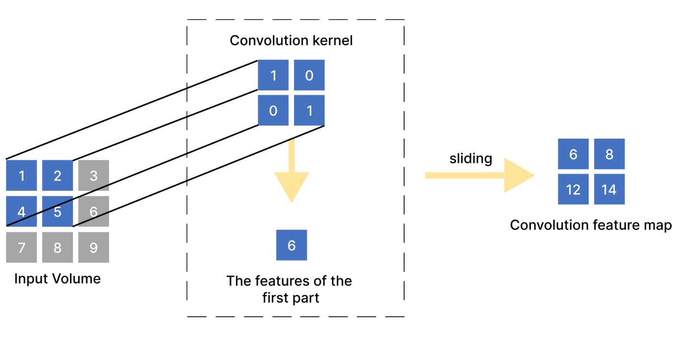

Figure 2.1 Convolution process.
After the convolution operation, the dimensions of the output feature map may not always be whole numbers. The size of the output feature map is determined using the following equation:
output size=$\left[\frac{input size-kernel size+2×padding}{stride}\right]1$

where:
input size represents the height or width of the input feature map,
kernel size is the dimension of the convolutional kernel,
padding determines the added border pixels around the input feature map,
stride refers to the step size of the convolutional kernel movement.

For example, given a 3 × 3 input feature map, a 2 × 2 convolutional kernel, with padding = 0 and stride = 1, the output size is calculated as:
output size=$\left[\frac{3-2+2×(2x0)}{1}\right]1=2$
Thus, the final output feature map size is 2 × 2.
TextCNN is a variant of the Convolutional Neural Network (CNN) designed for text classification [25]. Similar to CNNs in image processing, TextCNN applies convolutional operations to capture localized patterns in text, followed by pooling operations to reduce dimensionality. These extracted features are then processed through a fully connected layer for classification.
In TextCNN, text sequences are first transformed into word embedding vectors. Convolutional kernels are applied to these embeddings at various positions, extracting meaningful text-based features. The most significant features are selected via pooling layers, passed through a fully connected layer, and finally classified into malware or benign categories. By integrating convolutional filters of different sizes, TextCNN effectively captures local dependencies between API call sequences, making it highly effective for malware detection.
Long Short-Term Memory (LSTM) networks are a type of Recurrent Neural Network (RNN) specifically designed to handle long-term dependencies in sequential data. Unlike traditional RNNs, which suffer from vanishing gradient problems, LSTMs utilize a gate mechanism to retain relevant information over long sequences.
LSTM Gate Mechanism
Forget Gate: Determines which past information should be discarded.
f_{t}​=σ(W_{f}​h_{t}−1​+W_{f}​x_{t}​+b_{f}​)
where:
W_{f}​ represents the weight matrix,
h_{t−1}​ is the previous hidden state,
x_{t​} is the current input,
b_{f​} is the bias,
σ denotes the sigmoid activation function.
Input Gate: Decides which new information should be stored.
i_{t}​=σ(W_{i}​h_{t}−1​+W_{i}​x_{t}​+b_{i}​)
$\tilde{C_{t}}$=tanh(W_{c}​h_{t}−1​+W_{c}​x_{t}​+b_{c}​)

where $\tilde{C_{t}}$represents an intermediate memory state.
Cell State Update: Updates the memory cell by incorporating new and retained information.
C_{t}​=f_{t}​∗C_{t}−1​+i_{t}​∗$\tilde{C_{t}}$
Output Gate: Determines the final output of the hidden state.
o_{t}​=σ(W_{o}​h_{t}−1​+W_{o}​x_{t}​+b_{o}​)
h_{t}​=o_{t}​∗tanh(C_{t}​)
At each time step, the model selects, updates, and stores relevant information, ensuring that long-term dependencies in API call sequences are preserved.
Since API call sequences exhibit both local dependencies (short-term behavior patterns) and long-range dependencies (behavior evolution over time), we propose an integrated CNN-LSTM model for malware detection.

CNN layers extract localized features from short API call patterns, identifying frequently occurring sequences.
LSTM layers capture long-term dependencies in malware execution sequences, preserving the contextual flow of API calls.
The combined CNN-LSTM model is optimized using cross-entropy loss and trained using backpropagation through time (BPTT).
This hybrid model enables robust malware detection, leveraging the spatial feature extraction of CNNs and the temporal pattern recognition of LSTMs, improving overall classification accuracy and generalization capabilities.
Our approach significantly enhances malware detection performance by leveraging deep learning-based sequence modeling, providing a more comprehensive and scalable solution for next-generation malware classification systems
2.1
The overall architecture of our classification system is depicted in Figure 2, illustrating the complete framework for malware classification.
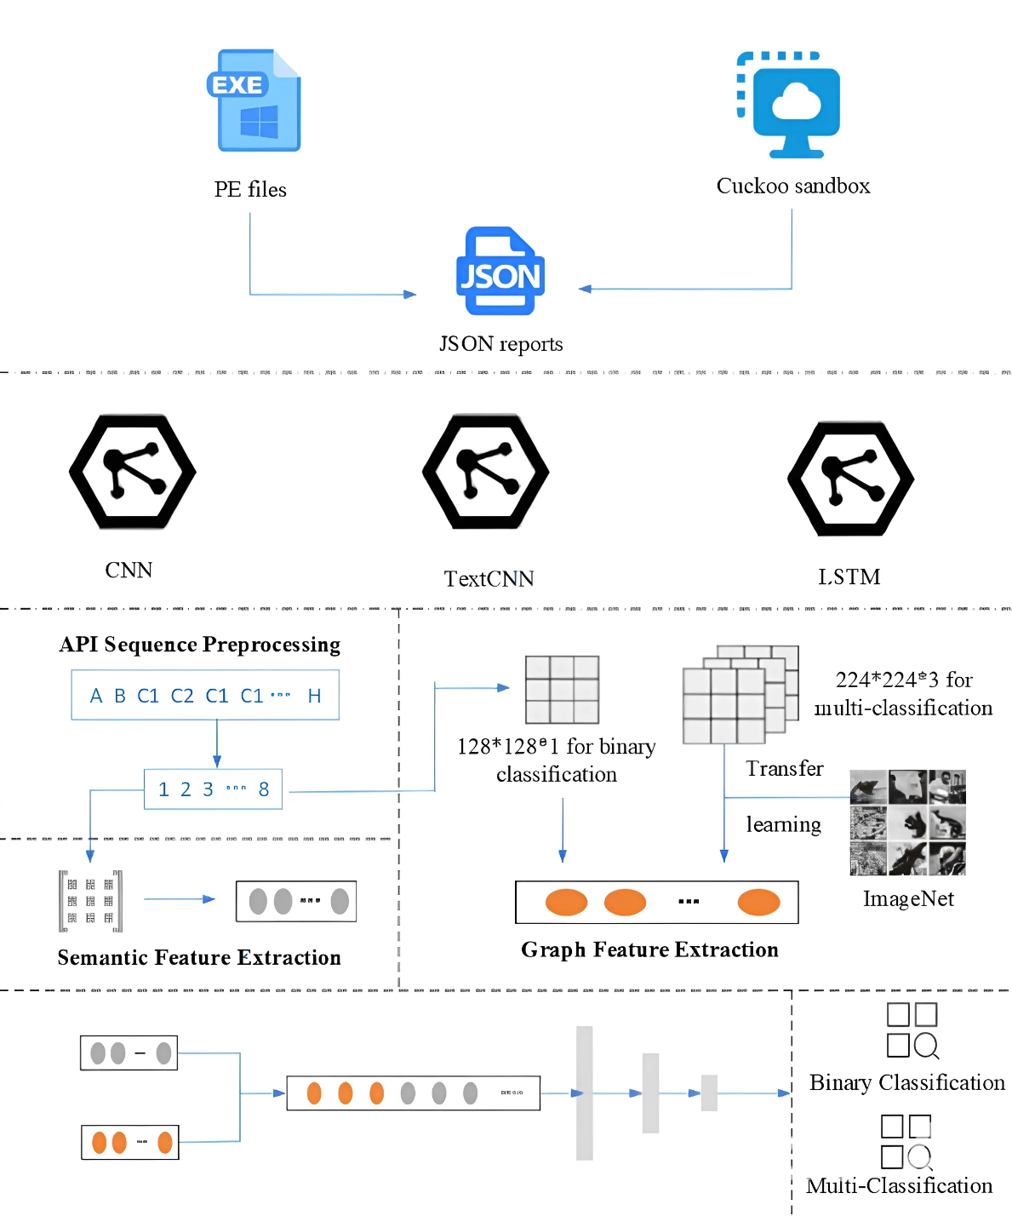
Figure 2.2 Framework Overview.
The system takes Portable Executable (PE) files as input and applies supervised deep learning techniques to perform both binary and multi-class classification of malware. The proposed approach consists of three key modules: the API sequence preprocessing module, the graph-based feature extraction module, and the semantic feature extraction module. Each of these modules plays a critical role in analyzing and classifying malware with high accuracy.
The API sequence preprocessing module is responsible for extracting API call sequences from the sample program. Each API call is assigned a unique numerical identifier to facilitate processing and improve computational efficiency. To refine the extracted data, redundant or non-informative API calls are eliminated, ensuring that only relevant API sequences are retained for analysis.
The graph-based feature extraction module transforms the preprocessed API call sequences into grayscale graphs, allowing for visual representation of the API call relationships. This transformation enables the system to leverage the pattern recognition capabilities of Convolutional Neural Networks (CNNs), which can identify key features such as pairwise API interactions, frequency distributions, and structural relationships. These extracted features provide insights into the behavioral patterns of malware, improving the overall classification accuracy. Additionally, an attention mechanism is incorporated to focus on the most relevant features, ensuring that essential behavioral characteristics are emphasized while reducing noise.
The semantic feature extraction module applies deep-learning models specifically designed for text sequence analysis. Techniques such as TextCNN and Long Short-Term Memory (LSTM) networks are employed to extract meaningful representations from API call sequences. These models analyze both the sequential and contextual relationships between API calls, capturing temporal dependencies and functional correlations. The extracted semantic features complement the graphical features, providing a more comprehensive view of the malware’s execution behavior.
Once the key features are extracted, they are processed by a CNN-based classifier, which performs the final malware classification. This classification step determines whether the input PE file belongs to a known malware family or is a benign application. By integrating both graph-based and semantic-based feature extraction, the system achieves higher accuracy and robustness in detecting various types of malware.
Transfer learning has emerged as a powerful technique in deep learning, allowing models to leverage knowledge from pre-trained networks and apply it to new tasks. It is particularly beneficial when dealing with limited training data, as it reduces the dependence on large labeled datasets by adapting pre-trained models to new domains. Transfer learning enables the model to utilize learned feature representations from one domain and transfer them to a related domain, improving generalization and reducing training time. Formally, transfer learning operates within a domain D consisting of a feature space X and a marginal probability distribution P(x), where x={x1,x2,...xn}∈X. The goal is to transfer knowledge from a source domain D_{s}​ to a target domain D_{t}​, where a task is defined as T={Y,f(⋅)}, with Y representing the label space and f(⋅) denoting the objective function. Since the objective function is not directly observable, it must be learned from training samples.
In typical transfer learning applications, there is one source domain and one target domain. The source domain Ds={(x_{s1},y_{s1}),(x_{s2},y_{s2}),...(x_{sn},y_{sn})} consists of data samples x_{si}∈X_{s}​ and their corresponding labels y_{si}∈Y_{s}​. The target domain Dt={(x_{t1},y_{t1}),(x_{t2},y_{t2}),...(x_{tn},y_{tn})} includes samples xt_{i}∈X_{t}​ and labels y_{ti}∈Y_{t}​. Typically, the number of labeled samples in the target domain ntn_tnt​ is much smaller than in the source domain n_{s}​, satisfying the condition 1≤n_{t}≪n_{s1}​.
​ In our proposed model, transfer learning is applied to enhance the multi-class malware classification task. The source domain 𝐷_{𝑠} is represented by the ImageNet dataset, which contains a vast collection of labeled images pre-trained on deep CNN architectures. The target domain
𝐷_{𝑡} consists of the collected malware dataset, where our classification model is fine-tuned for malware detection. We implement transfer learning using the VGG16 network, a widely used deep-learning model for image classification, and leverage PyTorch as the primary framework for model training and optimization.
By applying transfer learning, the model benefits from pre-learned feature representations, reducing the need for large-scale labeled malware samples while improving classification accuracy. This approach allows the model to generalize better to unseen malware samples, ensuring high detection performance even when training data is limited. Transfer learning, combined with the proposed graph-based and semantic feature extraction techniques, provides a robust and scalable framework for malware classification, effectively distinguishing between benign and malicious files.
The first step in our proposed approach involves preprocessing API call sequences to ensure accurate and efficient malware detection. To achieve this, we utilize CAPE sandbox in a virtual machine environment, allowing isolated execution of Portable Executable (PE) files within a controlled sandbox. This setup ensures that each sample is analyzed in a secure and independent environment.
For batch execution, each PE file is loaded into the sandbox, where it runs in an isolated virtual machine. Once execution is completed, the virtual machine reverts to a pre-saved normal snapshot state, ensuring that each subsequent sample is executed in a clean environment without interference from previous executions. This process continues iteratively until all benign and malicious samples have been executed.
After execution, the system stores the results in separate folders, categorizing them as benign or malicious based on the behavioral patterns observed during execution. The Host Machine then generates an analysis report for each sample, containing detailed execution characteristics such as program snapshots, API and DLL calls, extracted strings, stored files, process and thread information, and other runtime behaviors.
Since our primary focus is on API call sequences, we extract only the relevant API call segments from the report. The analysis process involves parsing the JSON file generated by the sandbox and pinpointing nodes associated with dynamic behaviors. By tracking API calls at each timestamp and navigating the relevant JSON nodes, we reconstruct the API call sequence in chronological order.
Algorithm 1 illustrates the step-by-step process of retrieving API sequences from the sandbox reports. The algorithm takes sandbox report paths as input, processes each report file, and extracts the API call sequences for further feature extraction and classification. This structured and chronological ordering of API sequences ensures that the extracted data maintains the temporal relationships between API calls, which is essential for accurate malware detection and classification.
Algorithm 2.1 Get API Sequences

Require: Report Path from Cuckoo
Ensure: API Call Sequences

1. Calls ← NULL
2. for each folder in Path do
3. if 'report.json' exists then
4. jsData ← load JSON data from 'report.json'
5. repDict ← NULL
6. callList ← NULL
7. if behavior not in jsData then
8. skip to next iteration
9. end if
10. md5 ← find md5 from jsData
11. repDict['md5'] ← md5
12. call ← jsData['behavior']['processes']['calls']
13. if call exists then
14. append call['api'] to callList
15. end if
16. repDict['callList'] ← callList
17. append repDict to Calls
18. else
19. skip to next iteration
20. end if
21. end for
22. return Calls

The raw API call sequence obtained from program execution tends to be excessively long, making it computationally expensive to analyze using deep neural networks. If the entire sequence were used as input, the dimensionality would become too large, leading to increased model complexity, excessive computational costs, and potential overfitting. To address this, we employ a sequence selection and optimization strategy to extract meaningful API call sequences while maintaining critical behavioral patterns.
API call sequences often contain redundant and repetitive patterns, as malware frequently invokes the same API calls multiple times during execution. To reduce redundancy, we traverse the entire sequence, identifying and removing continuously repeated subsequences while preserving critical behavioral characteristics. This step reduces noise, enhances model interpretability, and ensures that the API sequence represents distinct malicious behaviors.
Table 1 illustrates the API call sequences before and after redundancy removal. After preprocessing, the resulting API call sequences exhibit a broader behavioral span and an optimized sequence length, making them more suitable for neural network training. Prior research [26] has shown that malicious activities often manifest within the first two minutes of execution. This finding guided our decision to truncate sequences to a length of approximately 1000 API calls, ensuring that key malicious behaviors remain captured while maintaining computational efficiency.
Furthermore, many malware samples contain fewer than 1000 API calls after preprocessing. Therefore, a sequence length of 1000 API calls was chosen as an optimal tradeoff between computational cost and detection accuracy. In subsequent experiments, we will further investigate the impact of varying sequence lengths to refine the sequence truncation strategy.
To standardize the representation of API calls, we compiled a dictionary containing all unique API calls observed in the dataset. Each API call is assigned a unique numerical identifier, allowing efficient processing in neural networks. This transformation ensures that API call sequences can be numerically encoded for input into deep-learning models, enabling effective feature extraction and malware classification.
Table 2.1 API sequence deduplication.
Complete Sequence | Remove Repetitive Subsequences
NtOpenKey
GetSystemTimeAsFileTime | NtOpenKey
NtQuerySystemInformation | GetSystemTimeAsFileTime
NtAllocateVirtualMemory | NtQuerySystemInformation
NtAllocateVirtualMemory | NtAllocateVirtualMemory
NtAllocateVirtualMemory | LdrGetDllHandle
LdrGetDllHandle

In this module, we transform the preprocessed API call sequence into a grayscale image representation to facilitate deep-learning-based feature extraction. Convolutional Neural Networks (CNNs) are highly effective for image feature extraction and classification, making them a suitable choice for analyzing malware behaviors based on graphical representations of API call sequences.
To optimize computational efficiency, we carefully assessed the tradeoff between dataset size and classification performance. While increasing the number of APIs beyond a certain threshold could theoretically improve performance, our experiments revealed that using a larger set of API calls resulted in excessive computational overhead without yielding significant classification improvements. Consequently, we selected the first 1000 APIs from each sample as the initial dataset for generating grayscale images, ensuring minimal resource consumption while preserving key behavioral patterns.
To convert an API call sequence into a 2D grayscale image, we initialize an N×N matrix, where NN represents the total number of unique APIs in the dataset (denoted as X). Initially, all matrix values are set to zero. During preprocessing, each API is mapped to a unique numeric identifier, allowing it to be systematically associated with specific rows and columns in the matrix.
The transformation process is structured as follows:
Suppose an API A_{i} is assigned a numerical index ii, and another API A_{j} is assigned index j.
As we traverse the API call sequence, each occurrence of A_{i}→A_{j} (where API A_{i} is followed by API A_{j} in the sequence) updates the corresponding matrix element Arr[i][j].
Each occurrence of this transition increments the value Arr[i][j] by a predefined threshold nn, which determines the grayscale pixel intensity.
This mapping effectively captures the frequency and structural relationships between API calls, encoding behavioral interactions into graph-based features. The resulting grayscale images serve as input for CNN-based deep-learning models, which extract spatial patterns and structural dependencies from API sequences to enhance malware classification.
Algorithm 2 presents the complete process for batch-processing API call sequences, converting them into graph representations for classification. This graph-based encoding method allows CNNs to leverage spatial hierarchies in malware execution behaviors, significantly improving detection accuracy while maintaining computational efficiency.
Algorithm 2.2 Batch Retrieval of API Images

Require: API Call Sequences, pixel, batchSize
Ensure: API Images

1. APIs ← API Call Sequences, Pixel ← The increased pixel value per call
2. Initialize Arr as a 342 x 342 (N × N) 2D array with zeros
3. numBatches ← ⌊(len(APIs) + batchSize – 1) ÷ batchSize⌋
4. for each batchIndex in [0, numBatches – 1] do
5. batchStart ← batchIndex × batchSize
6. batchEnd ← min((batchIndex + 1) × batchSize, len(APIs))
7. imageList ← NULL
8. for each idx in [batchStart, batchEnd – 1] do
9. Seq ← APIs[idx]
10. Reset array Arr to all zeros, i ← 1, len ← len(Seq) – 1
11. for i to len(Seq) do
12. api₁ ← Seq[i – 1]
13. api₂ ← Seq[i]
14. if Arr[api₁ – 1][api₂ – 1] ≥ 255 then
15. Arr[api₁ – 1][api₂ – 1] ← 255
16. else
17. Arr[api₁ – 1][api₂ – 1] ← Arr[api₁ – 1][api₂ – 1] + Pixel
18. end if
19. end for
20. GralIMG ← Convert Arr to grayscale image
21. Append GralIMG to imageList
22. end for
23. end for
24. return imageList

In our approach, the API call sequence matrix is converted into a grayscale image, where each matrix value is mapped to a pixel intensity between 0 and 255. However, to ensure that the model can effectively distinguish between malware and benign samples, careful consideration is given to the selection of the grayscale pixel threshold n.
Since 255 is the maximum allowable pixel intensity, any matrix value exceeding this threshold is automatically clipped to 255. This can lead to over-saturation, where many API call relationships are represented at the same maximum intensity, potentially reducing the model’s ability to differentiate between distinct malware behaviors. To minimize such occurrences, the value of n must be carefully chosen.
After preprocessing, each program retains only 1000 API calls, effectively reducing noise from consecutive repetitive calls. This helps prevent excessive accumulation of matrix values that could otherwise lead to over-saturation at 255 pixel intensity. The goal is to balance pixel distribution, ensuring that the CNN can effectively learn from the extracted features.
To determine an appropriate threshold increment 𝑛, we first analyzed the frequency of API call pairs. In our dataset, after duplicate elimination, the average frequency per call pair was found to be around 10 occurrences. This led us to initially choose a threshold increment between 10 and 25, ensuring that values remain spread out across the grayscale range rather than clustering around 255.
If longer API sequences are retained in future experiments, the value of n can be further adjusted downward to improve representation while keeping the number of over-saturated pixels minimal. This ensures that the CNN can still differentiate patterns effectively without losing important structural relationships due to pixel saturation.
Finally, we construct 𝑁×𝑁 grayscale images based on the 2D matrix representation of API sequences. Each pixel intensity in the grayscale image corresponds to the matrix value, resulting in a structured visual representation of API interactions. Figure 3 illustrates the final API sequence as a grayscale image, where distinct malware execution patterns become visible.
By fine-tuning the threshold selection and preprocessing API call sequences effectively, we ensure that our CNN-based model can extract meaningful patterns, leading to high accuracy in malware classification.
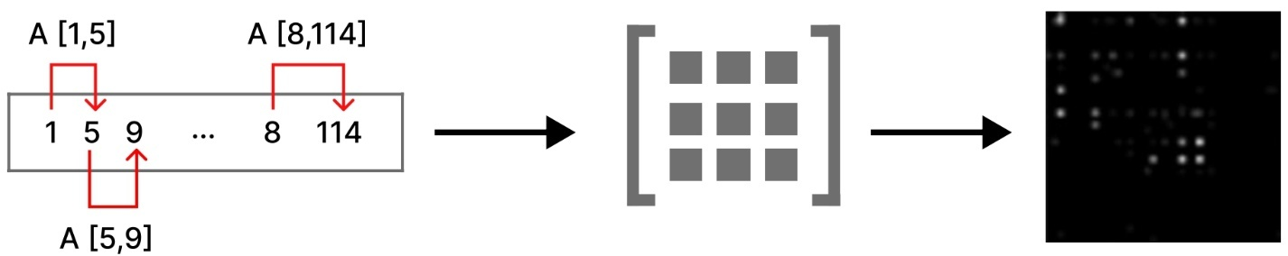

Figure 2.3 API sequence map to grayscale image.
Graph Feature Extraction Using CNNs and Attention Mechanisms - The graph feature extraction module constructs a grayscale image representation of the API call sequence, capturing both statistical features and call relationships. This graphical representation enables the use of deep-learning-based feature extraction via Convolutional Neural Networks (CNNs), which are highly effective for pattern recognition and classification.
To optimize CNN processing, we experimented with varying API sequence lengths. Initially, increasing the number of APIs beyond a certain threshold did not improve classification performance but significantly increased computational overhead. Therefore, we standardized the input API sequence length to 1000, ensuring efficient feature extraction with minimal computational cost.
The graph transformation process follows these steps:
The preprocessed API call sequence is mapped to an N×N matrix, where N represents the total number of unique APIs in the dataset.
Each API is assigned a numeric representation, and transitions between API calls are recorded in the matrix.
The matrix is then converted into a grayscale image, with pixel intensities normalized to prevent saturation at 255 while preserving significant frequency variations.
For feature extraction, we adopt a VGG-based CNN architecture, employing:
Small convolutional kernels to capture local relationships,
Max pooling layers to downsample feature maps and reduce overfitting,
ReLU activation functions to introduce non-linearity,
An attention mechanism to focus on high-resolution regions while filtering out noise.
The attention module dynamically assigns higher weights to critical regions in the grayscale image, improving feature extraction by emphasizing discriminative patterns while suppressing irrelevant noise. This refined feature representation is then passed through a Flatten layer, converting it into a 1D feature vector for classification.
The extracted grayscale image features primarily represent the frequency distribution and statistical relationships between API calls. However, since API sequences also contain semantic and temporal dependencies, we introduce a semantic feature extraction module to complement the graph-based approach.
To extract textual semantic features from API call sequences, we employ TextCNN and Bidirectional Long Short-Term Memory (Bi-LSTM) networks.
TextCNN for Multi-Scale Feature Extraction
TextCNN is a lightweight Convolutional Neural Network optimized for text classification. It is well-suited for extracting multi-scale semantic features from API sequences, efficiently capturing local dependencies while maintaining computational efficiency.
To transform API sequences into a format suitable for TextCNN, each API call is converted into a kk-dimensional vector. We initially tested one-hot encoding, but this method produced:
High-dimensional sparse matrices,
Significant storage overhead,
Inefficient feature extraction.
Instead, we adopted a word embedding approach, which offers:
Compact vector representations,
Preservation of API relationships,
Reduced computational resource consumption.
The API call sequence is thus represented as a 2D matrix, where each row corresponds to an API call's vector representation. This matrix is fed into TextCNN, which applies:
2 × n, 3 × n, and 4 × n convolutional kernels,
Stride = 1 to ensure overlapping local context,
Pooling layers to retain only the most informative features.
This process enables multi-scale feature extraction, capturing both short-term dependencies and broader semantic structures within API sequences.
Bi-LSTM for Long-Range Dependency Extraction
Since API call sequences exhibit temporal dependencies, we employ Long Short-Term Memory (LSTM) networks to capture long-range relationships. LSTM overcomes the vanishing gradient problem in traditional RNNs by introducing three gates:
Input gate – Determines relevant information to retain.
Forget gate – Filters out redundant information.
Output gate – Generates the final feature representation.
To further enhance temporal modeling, we use a Bidirectional LSTM (Bi-LSTM), which processes sequences in both forward and backward directions, capturing dependencies that standard LSTMs might miss.
To maximize information extraction, we deploy three separate Bi-LSTMs, each trained on:
Short-term semantic features from TextCNN with small kernels.
Medium-range features from TextCNN with medium-sized kernels.
Long-range semantic dependencies from TextCNN with large kernels.
The outputs from all three Bi-LSTM layers are then concatenated, forming a comprehensive semantic representation of the API call sequence.
The final step in our model involves combining graph-based and semantic-based features to leverage the strengths of both representations. The grayscale image features capture statistical characteristics of API call frequencies, while the semantic features provide insights into the structural and temporal relationships within API sequences.
These combined features are then fed into a classifier, which makes the final decision on whether the given API sequence corresponds to benign or malicious behavior.
By integrating graph-based CNN features with semantic TextCNN + Bi-LSTM features, our approach provides:
Robust feature extraction,
Improved classification accuracy,
Reduced computational overhead,
Enhanced generalization to unseen malware samples.
This hybrid deep-learning model ensures high-performance malware classification, effectively differentiating between malicious and benign software based on comprehensive API call sequence analysis.

CHAPTER 3. IMPLEMENTATION AND PERFORMANCE EVALUATION

3.1 Development of the Proposed Malware Detection Model
In the field of cybersecurity, malware detection remains a critical challenge due to the increasing sophistication of malicious software. Traditional rule-based detection methods often struggle to keep pace with evolving threats, making machine learning and deep learning techniques essential for enhancing detection accuracy. By leveraging advanced neural network architectures and transfer learning, researchers can develop more robust and adaptive models for identifying malware.
This study explores the application of deep learning models, including ResNet-50, BiLSTM, and transfer learning, in malware detection. These architectures have demonstrated significant success in various domains, particularly in image and text classification. Their ability to extract complex patterns and learn hierarchical features makes them valuable tools for analyzing malware behavior and improving detection rates.
ResNet-50 is a convolutional neural network (CNN) architecture that belongs to the Residual Networks (ResNet) family. These networks were introduced to address the challenges associated with training very deep neural networks. Developed by researchers at Microsoft Research Asia, ResNet-50 is widely known for its efficiency and strong performance in image classification tasks. The ResNet family includes models of varying depths, such as ResNet-18 and ResNet-34, with ResNet-50 serving as a mid-range option.
Since its introduction in 2015, ResNet-50 has remained a significant milestone in the evolution of deep learning architectures.
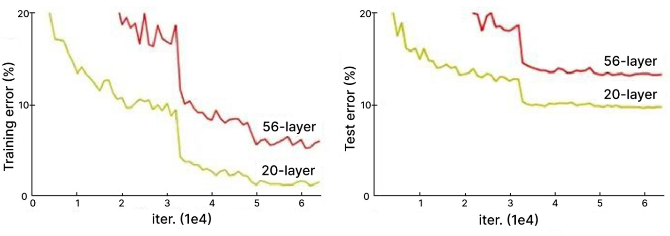
Figure 3.3 Training error (left) and test error (right) on CIFAR-10 with 20-layer and 56-layer “plain” networks. The deeper network has higher training error, and thus test error. (https://arxiv.org/pdf/1512.03385)
One of the key innovations of ResNet is its ability to mitigate the degradation problem that occurs in deep neural networks. As the number of layers increases, traditional networks tend to experience performance degradation rather than improvement. This issue arises not from overfitting but from difficulties in optimizing the training process.
ResNet overcomes this challenge through residual connections, which allow layers to learn identity mappings by skipping one or more layers. These shortcut connections make it easier for the network to propagate gradients during backpropagation, enabling the training of very deep networks without significant performance loss. This feature is particularly beneficial in tasks requiring complex pattern recognition, such as malware detection.
ResNet addresses this issue through Residual Blocks, which introduce shortcut connections that enable the direct flow of information across layers. These skip connections help prevent the vanishing gradient problem, ensuring efficient training even in very deep networks.
In ResNet-50, the primary building block is the Bottleneck Residual Block, which enhances computational efficiency while maintaining deep feature extraction capabilities. This block follows a specific architecture designed to reduce the number of parameters and improve training stability. The structure consists of:
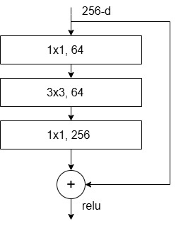
Figure 3.4 The Bottleneck Residual Block for ResNet-50/101/152 (https://arxiv.org/pdf/1512.03385.pdf)

Components of the Residual Block
ReLU Activation:
The Rectified Linear Unit (ReLU) activation function is applied following each convolutional and batch normalization layer. By allowing only positive values to pass through, ReLU introduces non-linearity, which is crucial for capturing complex patterns in the data.
Bottleneck Convolutional Layers:
This block consists of three convolutional layers, each followed by batch normalization and ReLU activation:
The first convolutional layer typically uses a 1×1 filter to reduce the number of channels in the input, which decreases computational complexity while preserving essential information.
The second convolutional layer often applies a 3×3 filter to extract spatial features from the data.
The third convolutional layer again utilizes a 1×1 filter, this time to restore the original number of channels before adding the output to the shortcut connection.
Skip Connection:
A defining characteristic of residual blocks is the shortcut connection, which enables the input to bypass the convolutional layers and be directly added to the output. This connection ensures that important information is retained and propagated through the network, preventing degradation of learned features when deeper layers struggle to capture additional patterns.
By integrating convolutional layers for feature extraction, maintaining an uninterrupted flow of information through skip connections, and utilizing a bottleneck structure to enhance efficiency, bottleneck residual blocks play a crucial role in ResNet-50. They help mitigate the vanishing gradient problem, facilitate the training of deep networks, and improve accuracy in image classification tasks.
Transfer learning involves utilizing the knowledge gained by a pre-trained machine learning model to solve a different yet related problem. For instance, if a model has been trained to recognize backpacks in images, the same learned knowledge can be adapted to identify other objects, such as sunglasses.
The core idea behind transfer learning is to leverage insights acquired from solving one task (Task A) and apply them to another (Task B) to enhance generalization. Instead of training a model from scratch, we start with pre-learned weights and patterns from a task with abundant labeled data and use them to improve performance on a task with limited data.
This approach is widely used in domains like computer vision and natural language processing (NLP), where training models from the ground up requires extensive computational resources. Although transfer learning is not a standalone machine learning technique, it is considered a strategic methodology within the field, particularly in deep learning, where large datasets and high computational power are necessary.
In computer vision, deep neural networks typically learn to detect edges in the initial layers, identify shapes in intermediate layers, and extract task-specific features in the final layers. In transfer learning, the early and intermediate layers are reused, while only the later layers are retrained. This process allows models to take advantage of previously labeled datasets without starting from zero.
The process of adapting pre-trained models to new tasks is known as fine-tuning. When applying transfer learning, we focus on two key types of layers:
Frozen layers: These layers retain their learned knowledge from the original task and remain unchanged during retraining.
Modifiable layers: These layers undergo fine-tuning to adjust their learning for the new, related task.
For example, if a model trained to identify backpacks in images is repurposed to detect sunglasses, the early layers that recognize general object features remain unchanged. Only the later layers are retrained to distinguish sunglasses from other objects.
By reusing knowledge from one domain to another, transfer learning significantly improves model efficiency and accuracy, especially when working with limited labeled data.
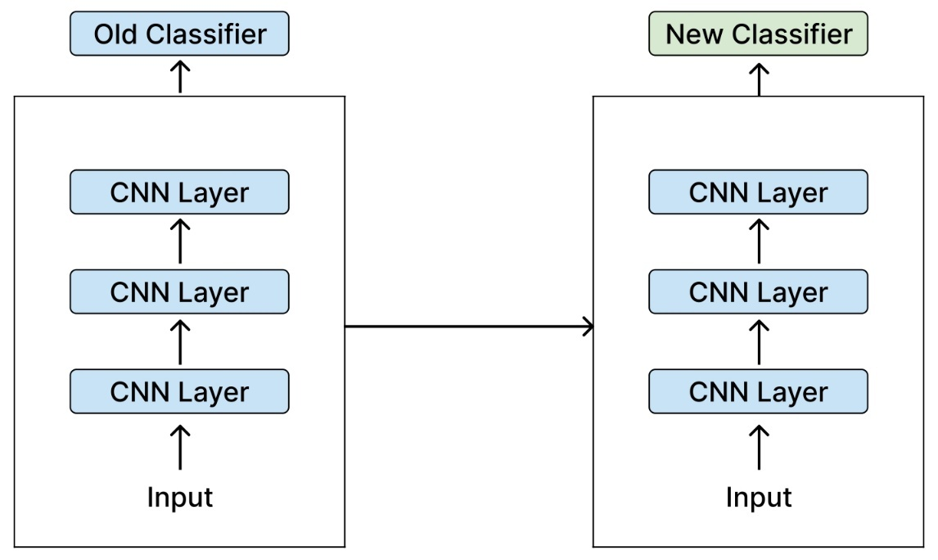
Figure 3.5 Transfer Learning: Replacing the Classifier in a CNN Model
Transfer learning offers several key benefits, including reduced training time, enhanced neural network performance (in most cases), and the ability to work with limited data.
Training a deep neural network from scratch typically requires a large amount of labeled data, which is not always available. However, by using a pre-trained model, transfer learning allows for effective machine learning with comparatively small datasets. This is especially useful in fields like natural language processing (NLP), where large labeled datasets require expert knowledge to construct. Additionally, transfer learning significantly reduces training time, which is crucial for complex deep learning tasks that can take days or even weeks to train from scratch.
While machine learning applications rarely follow strict rules, there are several scenarios where transfer learning is particularly beneficial:
Limited training data – When there isn’t enough labeled data to train a deep neural network from scratch.
Pre-trained models – If a model already exists that has been trained on a similar task with a large dataset, it can be repurposed.
Similar input data – When both the original and new tasks share the same type of input data (e.g., image-to-image tasks or text-to-text tasks).
If a model was originally trained using an open-source framework like TensorFlow, you can restore it and retrain specific layers to fit your new task. However, transfer learning is only effective if the features learned from the original task are general enough to be useful for the new task. Also, the input size must match the original model’s training dimensions—if not, a preprocessing step is needed to resize the input data accordingly.
Approaches to Transfer Learning
1. Training a Model for Reuse
If a deep learning model needs to be trained for Task A but lacks sufficient data, one solution is to find a related Task B with ample labeled data. By first training a model on Task B, the learned weights can then serve as a foundation for Task A. Depending on the problem, either the entire model or only certain layers can be reused.

If both tasks share the same input format, the pre-trained model can be used directly to make predictions.
Alternatively, adjusting and retraining task-specific layers—particularly the output layer—can improve adaptability.
2. Using a Pre-Trained Model
Another approach is leveraging an existing pre-trained model. Many such models are publicly available, making it easier to find one suited for a specific task. The number of layers that should be reused versus retrained depends on the problem and dataset.
For example, Keras offers a variety of pre-trained models that can be used for prediction, feature extraction, and fine-tuning. Additionally, research institutions frequently release trained models that can be adapted for various applications.
This method is widely used in deep learning due to its efficiency in reducing computational costs and improving accuracy on tasks with limited data.
Bidirectional Long Short-Term Memory (BiLSTM) is an advanced type of recurrent neural network (RNN) that improves upon traditional Long Short-Term Memory (LSTM) networks by capturing dependencies in both forward and backward directions. This dual-processing mechanism enables BiLSTMs to achieve superior performance in sequence-based tasks such as natural language processing (NLP), speech recognition, and time-series analysis.
Unlike standard LSTMs, which process data sequentially from past to future, BiLSTM consists of two LSTM layers—one processing input in the forward direction and the other in the backward direction. By combining these two representations, BiLSTM provides a more comprehensive understanding of the entire sequence, making it especially useful for context-dependent tasks.
A BiLSTM network consists of the following core components:
Forward LSTM Layer – Processes the input sequence from the beginning to the end, capturing dependencies from previous time steps.
Backward LSTM Layer – Processes the sequence in reverse, considering future dependencies while analyzing earlier time steps.
Concatenation Layer – Merges the outputs of both LSTM layers, allowing the model to incorporate information from both directions.
Output Layer – Processes the combined representation to make predictions for downstream tasks.
By leveraging this bidirectional structure, BiLSTMs retain information about both past and future words in a sequence, making them particularly useful for NLP applications like text classification, named entity recognition (NER), machine translation, and sentiment analysis.
BiLSTM networks offer several advantages over traditional LSTMs and RNNs:
Captures bidirectional dependencies – Unlike standard LSTMs that only consider past information, BiLSTMs integrate both past and future context, improving sequence understanding.
Better performance in NLP tasks – Since natural language often requires understanding the entire sentence structure, BiLSTMs significantly enhance tasks like part-of-speech (POS) tagging and sentiment analysis.
Reduces vanishing gradient issues – While LSTMs already mitigate the vanishing gradient problem present in traditional RNNs, BiLSTMs further enhance long-range dependency learning.
Improves contextual accuracy – By analyzing data in both directions, BiLSTM enhances model comprehension, which is crucial in translation and text generation tasks.
Applications of BiLSTM
BiLSTM is widely used in various domains, particularly in NLP and time-series forecasting:
1. Natural Language Processing (NLP)
Named Entity Recognition (NER) – Identifies proper nouns, locations, and other key entities in text.
Text Classification – Categorizes documents, reviews, and articles based on their content.
Machine Translation – Improves translation accuracy by considering sentence context in both directions.
Question Answering Systems – Enhances chatbot and AI assistant responses by understanding context.
2. Speech and Audio Processing
Speech Recognition – Converts spoken words into text by analyzing temporal dependencies.
Emotion Detection – Identifies sentiment in audio by capturing tone variations over time.
3. Time-Series Prediction
Stock Market Forecasting – Predicts trends based on historical market data.
Weather Prediction – Analyzes meteorological patterns to improve forecasting accuracy.
Having explored the advantages of BiLSTM in sequence modeling, we now extend its application to malware detection. Since malware analysis often involves sequential data—such as API call sequences, opcode sequences, or network traffic patterns—BiLSTM’s ability to capture dependencies in both past and future contexts makes it a powerful tool for identifying malicious behavior.
Traditional malware detection methods, such as signature-based and heuristic approaches, struggle with detecting newly evolved or obfuscated malware. In contrast, deep learning models like BiLSTM leverage temporal patterns and contextual information to enhance detection accuracy, even for zero-day threats.
In the next section, we will implement a BiLSTM-based malware detection system, demonstrating how its bidirectional structure improves classification performance by analyzing sequential patterns in executable files, logs, or system activities.

3.2 Performance Evaluation and Comparative Analysis
The experimental framework utilized for training and testing in this study was implemented in a computational environment featuring a system with 32GB of RAM, an Intel Core i9-11900H processor, and an NVIDIA GeForce RTX 3080 graphics card. To ensure secure execution and analysis of both malicious and benign software, we established an isolated sandbox environment using Cuckoo Sandbox on the Ubuntu 22.04 operating system. Additionally, a separate virtualized Windows environment was configured within VMware Workstation to execute potentially harmful software securely. Our deep learning models were developed and executed on a Windows 11 operating system using Python 3.10, Anaconda 5.0, and TensorFlow version 2.9, providing a robust foundation for the experimental workflow.
For the experimental study, we utilized two distinct datasets, referred to as Dataset X and Dataset Y, each serving different classification objectives. Dataset X was specifically designed for binary classification, where the goal was to distinguish between benign and malicious software samples. The dataset was constructed by sourcing malicious executable files from publicly available malware repositories such as ANY.RUN and Hybrid Analysis, whereas benign software samples were obtained from verified open-source repositories to ensure authenticity and integrity. To facilitate accurate data collection, each sample was executed within the Cuckoo Sandbox under controlled conditions for a duration of ten minutes, during which relevant API call sequences were monitored and extracted from the sandbox reports. These reports were parsed from XML format to isolate the API call sequences, followed by a preprocessing stage that removed redundant sequences to enhance data quality. Ultimately, Dataset X comprised 2500 benign software samples and 2500 malware samples, each represented by their respective API call sequences. This dataset was utilized to assess the effectiveness of our classification approach in detecting malicious software.
In contrast, Dataset Y was structured to facilitate multi-class classification, focusing on differentiating various types of malware. This dataset was derived from the work of Smith et al. [27], where researchers meticulously collected and validated malware samples using VirusTotal as a benchmark for categorizing malicious API call behaviors specific to Windows operating systems. Dataset Y included a diverse range of malware categories, encompassing ten prevalent types such as ransomware, rootkits, Trojans, and adware. These malware families exhibit distinct behavioral patterns, making the dataset a valuable resource for capturing a broad spectrum of malicious activities observed in real-world cyber threats. Table 2 provides a detailed breakdown of the specific malware categories and their respective sample counts within Dataset Y.
To ensure rigorous model evaluation and generalization capability, both datasets were partitioned into training and testing subsets. Specifically, 70% of the data was allocated for training, while the remaining 30% was reserved for testing purposes. Notably, the malware samples present in the test set were not included in the training set, ensuring that the model was exposed exclusively to previously unseen malicious instances during evaluation. This methodology was implemented to gauge the model’s ability to detect novel malware effectively and assess its generalization performance in identifying emerging threats in cybersecurity landscapes.
To systematically assess the performance of our approach, we employed four widely recognized evaluation metrics frequently utilized in malware classification research: Accuracy, Precision, Recall, and F1-score. These metrics were chosen to provide a comprehensive evaluation of the model’s effectiveness in identifying malware while balancing false positives and false negatives. Accuracy measures the overall correctness of predictions, Precision quantifies the proportion of correctly identified malicious samples among those classified as malware, Recall evaluates the model’s ability to detect all actual malware instances, and F1-score provides a harmonic mean between Precision and Recall, ensuring a balanced performance assessment.
This experimental setup was designed to ensure a robust, secure, and reliable evaluation of our deep learning-based malware detection system. By leveraging a well-structured dataset, a carefully controlled sandboxing approach, and a systematic evaluation methodology, we aimed to validate the efficacy of our approach in detecting and classifying malware with high accuracy and robustness against unseen threats.
Table 3.1 Malware Family and Samples
Malware | Samples
Spyware | 745
Downloader | 980
Trojan | 1150
Worms | 920
Adware | 410
Dropper | 760
Virus | 1075
Backdoor | 940
Ransomware | 890
Rootkit | 670
Keylogger | 580

To analyze the impact of individual components on the experimental results, we trained and evaluated four different models based on distinct feature extraction techniques: image-based features, semantic-based features, a model without the attention mechanism, and our proposed hybrid approach. For image-based features, we transformed the API call sequences into grayscale images, which were then processed by a Convolutional Neural Network (CNN) to extract spatial patterns. The output feature maps were passed through a Flatten layer to convert them into one-dimensional vectors, followed by fully connected layers and a softmax activation function to generate the final classification results.
For semantic-based feature extraction, the API call sequences were directly used as neural network inputs. Three convolutional filters with varying kernel sizes were applied to capture sequence dependencies, and the extracted features were further refined using multiple Bi-LSTM layers to capture long-term dependencies within the data. The final output vectors were concatenated and passed through a fully connected layer with a softmax activation function to produce the classification results.
Table 3.2 Time Consumption Details
Module | Times (s)
API Sequence Preprocess | 1385
Feature Vector Generation | 45
Training the model | 3690
Total | 5120
We also evaluated a model without an attention mechanism to compare its performance against our proposed method. Our final hybrid approach integrates both image-based and semantic-based features, enhancing the classification accuracy by leveraging spatial and sequential characteristics of API call sequences. The combination of CNNs for spatial representation and Bi-LSTMs for sequence learning provided a more comprehensive feature extraction pipeline, improving the model’s ability to detect various types of malware. Figure 5 presents a comparative analysis of the evaluation metrics for all four models.
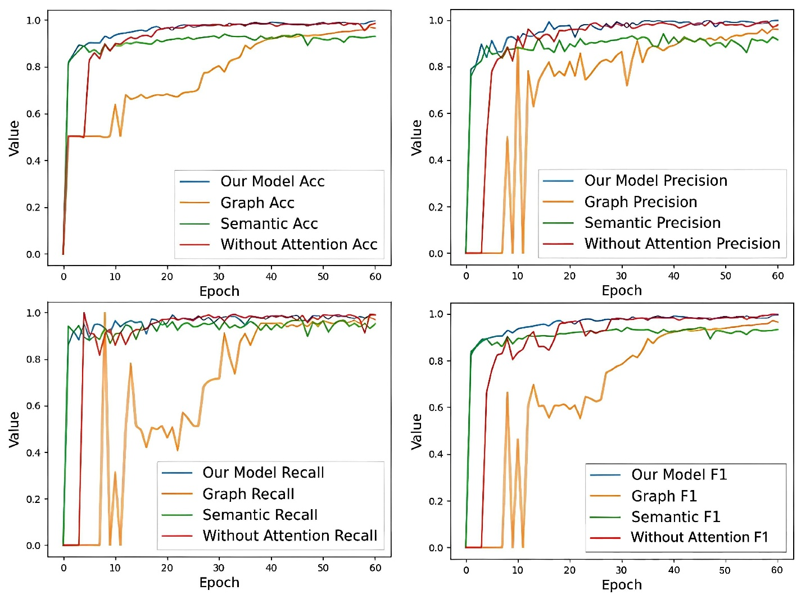
Figure 3.6 Acc, Precision, Recall and F1 training results.
To assess the effectiveness of our methodology, we conducted classification tests using both Dataset X and Dataset Y. Initially, we implemented binary classification on Dataset X by utilizing a custom-designed deep learning model consisting of a four-layer Convolutional Neural Network (CNN) for feature extraction. The training process stabilized and converged after approximately 70 epochs. Our experiments indicate that relying solely on image-based features resulted in a classification accuracy of 96.8%, whereas using only semantic-based features led to an accuracy of 91.5%. These results demonstrate that both feature extraction techniques exhibit strong classification capabilities when applied to API call sequences. However, our proposed hybrid approach, which integrates image-based and semantic-based features, achieved a significantly higher classification accuracy of 99.35%. This improvement highlights the advantages of combining multiple feature extraction methodologies to enhance model performance. Furthermore, our method outperformed other models across multiple evaluation metrics, demonstrating its robustness and effectiveness in malware classification.
One of the key challenges in API sequence-based malware classification is the presence of infrequent API calls, which may introduce noise in feature extraction. To address this issue, we implemented an attention mechanism in the image-based feature extraction module to prioritize critical information while reducing the influence of less significant data points. By introducing this attention-based enhancement, classification accuracy improved by approximately 1.2%, confirming the importance of adaptive feature selection. The process of converting API call sequences into grayscale images proved to be highly effective, as these images visually represent API call frequencies and the interdependencies between different API calls. CNNs, known for their superior performance in image recognition tasks, successfully captured these patterns, leading to enhanced malware classification accuracy.
In addition to CNN-based feature extraction, we leveraged sequence-based neural networks, including TextCNN and Bi-LSTM, to analyze the sequential characteristics of API call sequences. By applying convolutional layers with multiple kernel sizes, we extracted diverse semantic patterns that reflect variations in API usage patterns. Unlike traditional N-gram-based text feature extraction, our approach utilizes convolutional operations on word embeddings, thereby capturing richer contextual relationships between API calls. This methodology enables the model to encapsulate various malware behavior patterns, including API call frequencies, execution orders, and interdependencies. As a result, our approach yielded superior classification accuracy by effectively distinguishing between benign and malicious software samples.

Table 3.3 Comparison of different threshold values (n).
Value of Increased Pixels (n) | Accuracy | Recall | Precision | F-Measure
1 | 92.8 | 91.75 | 94 | 92.85
5 | 94.1 | 92.3 | 96.2 | 94.2
10 | 95.45 | 94.5 | 97.1 | 95.75
20 | 99.5 | 99.8 | 99.85 | 99.6

We examined the impact of varying the threshold for pairwise API call mapping in the grayscale image module. The threshold values were set at 1, 5, 10, and 20 to evaluate how different configurations influence classification performance. After conducting 70 training epochs, the classification results on the test set, detailed in Table 4, reveal the effect of adjusting on model accuracy and feature extraction quality. This investigation further validates our approach by demonstrating how different preprocessing strategies impact malware detection efficiency.
As depicted in Figure 6, an increase in the pixel values of the grayscale representation leads to a gradual enhancement in classification performance. When the threshold is set to 1, meaning that for every API call between A and B, the corresponding matrix value increments by 1, the resulting grayscale image has relatively low pixel intensity. Under this condition, the classification accuracy is the lowest, reaching only 92.80%. However, as the threshold increases, the accuracy improves significantly. For instance, setting to 5 and 10 results in classification accuracies of 94.10% and 95.45%, respectively. This trend indicates that incorporating a higher threshold value allows for a more robust representation of API call dependencies, leading to enhanced classification outcomes. Moreover, precision, recall, and F1-score metrics exhibit a similar pattern of improvement.
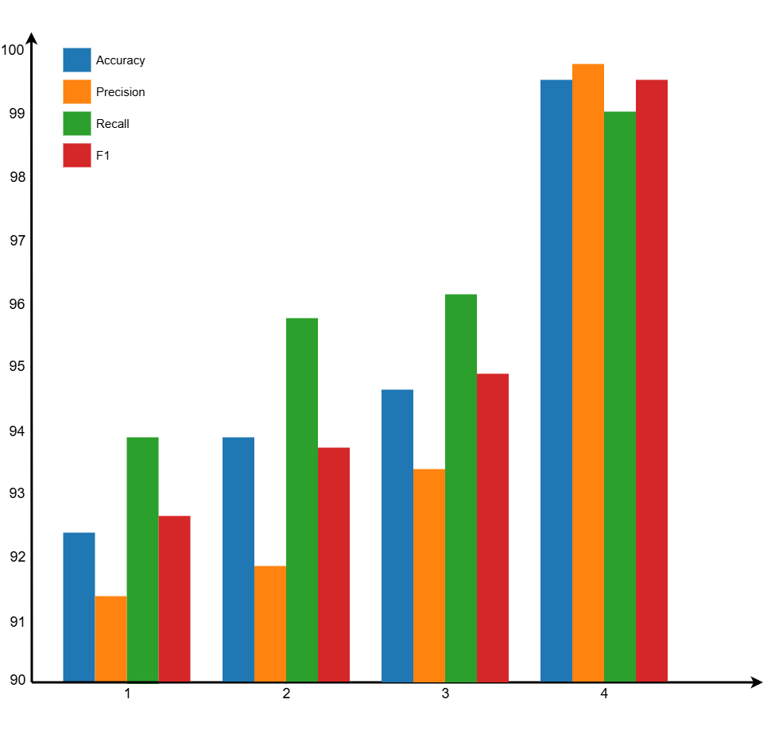
Figure 3.7 Comparison of different threshold values (n).
Our methodology selects at 20, yielding a peak classification accuracy of 99.50%. This choice is influenced by the preprocessing strategies that minimize redundant API call sequences while preserving meaningful patterns. A higher threshold value effectively highlights the relationships between API calls, strengthening the discriminatory power of the model. However, excessively large values or datasets with numerous repetitive API calls may cause pixel values in the feature matrix to surpass 255, which is the maximum intensity for an 8-bit grayscale image. When values exceed this limit, they are clamped at 255, potentially leading to information loss and reduced classification accuracy. This limitation underscores the importance of balancing feature representation and avoiding excessive saturation in the feature extraction process.
In addition, we investigated the effect of sequence truncation on malware classification performance using Dataset X. During preprocessing, we systematically removed consecutive duplicate API calls to enhance data quality. Identifying an optimal truncation threshold was crucial to preserving key behavioral patterns of malware while mitigating unnecessary noise. Premature truncation risks discarding critical behavioral indicators, thereby preventing the model from fully capturing malicious intent. Conversely, excessive sequence length introduces redundant or irrelevant information, diluting the distinctive characteristics essential for accurate classification.
To determine an appropriate truncation threshold, we experimented with different truncation points at 200, 500, 800, 1000, and 1200 sequence lengths. The classification results, obtained after 50 training epochs, are presented in Table 5. As truncation length approached 1000, the model exhibited increasing accuracy, reaching a peak performance of 99.50%. However, when truncation was extended beyond 1000 to 1200, the classification performance declined. This decline suggests that by 1000 sequence length, the dataset sufficiently encapsulates the behavioral traits necessary for effective malware identification. Truncating before 1000 omits valuable malicious activity, whereas truncating beyond 1000 introduces an excess of benign operations, such as memory deallocation and handle closures, which are common in both benign and malicious samples. This extraneous information can obscure key discriminative features, negatively impacting the model’s performance. Thus, the experimental results validate 1000 as the optimal truncation point for malware classification in our study.
Table 3.6 Comparison of different sequence truncation
Value of Sequence Truncation | Accuracy | Recall | Precision | F-Measure
200 | 94.5 | 94.8 | 94 | 94.4
500 | 96.8 | 95.2 | 99.2 | 96.5
800 | 97.85 | 96.5 | 99.75 | 97.6
1000 | 99.5 | 99.8 | 99.85 | 99.65
1200 | 98.9 | 99.1 | 98.9 | 98.85

To further verify the robustness and reliability of our proposed method, we extended our experiments to Dataset Y, which involved multi-class classification tasks. Unlike binary classification, multi-class classification requires a more detailed and complex feature extraction process. To enhance the model’s capability in identifying diverse malware families, we experimented with multiple deep learning architectures for image-based feature extraction. Specifically, we evaluated the performance of pre-trained convolutional neural networks, such as ResNet50, VGG19, and DenseNet121, which were originally trained on ImageNet. Using transfer learning, we fine-tuned these models to serve as feature extractors for malware images. The preprocessing step involved resizing and augmenting the images, ensuring they conformed to a standardized input size of 224 × 224 × 3 before being fed into the neural network.
To assess the effectiveness of various feature extraction methods, we compared different architectures in both image-based and sequence-based processing modules. In the semantic information extraction module, we implemented a combination of Bi-LSTM and GRU networks. GRU, being a variant of LSTM, has a simpler structure with fewer parameters, enabling faster training speeds. In contrast, Bi-LSTM captures bidirectional dependencies within API sequences, allowing the model to learn from both past and future API interactions. Meanwhile, in the image feature extraction module, we compared the effectiveness of ResNet, VGG, and DenseNet in classifying malware families. After training for 50 epochs, the classification results are summarized in Table 6.
According to the results, the combination of VGG19 and Bi-LSTM yielded the highest accuracy in the multi-class classification task, achieving an overall accuracy of 99.72%. The superior performance of Bi-LSTM and Bi-GRU compared to unidirectional models highlights the importance of capturing both forward and backward sequence dependencies in API call sequences. This confirms that bidirectional networks significantly improve the model’s ability to differentiate malware families. Furthermore, while GRU offers computational efficiency due to its reduced parameter count, it lags behind LSTM in classification accuracy, particularly in detecting sophisticated malware types such as Rootkits and Backdoors. The results also indicate that VGG19 outperforms other CNN architectures in image-based malware classification, effectively capturing the structural characteristics of API-call-generated images. In contrast, AlexNet demonstrated significantly weaker classification performance, struggling to extract meaningful features from the grayscale representations of API sequences.
We investigated the impact of transfer learning on classification performance. Given that AlexNet failed to effectively classify malware families, it was excluded from further comparisons. We evaluated the performance of different neural network combinations with and without transfer learning, analyzing their impact on feature extraction and classification accuracy. The experimental results of this comparative study are presented in Table 7, illustrating the substantial performance gains achieved through transfer learning techniques.
Table 3.7 Comparison of different networks on Dataset B.
 |  | ResNet50+  BiLSTM | ResNet50+  LSTM | ResNet50+  BiGRU | ResNet50+  GRU | DenseNet121+  BiLSTM | DenseNet121+  BiGRU
 | ACC | 0.9972 | 0.9825 | 0.995 | 0.9842 | 0.9981 | 0.996
Adware | Precision | 1 | 1 | 1 | 1 | 1 | 1
 | Recall | 1 | 1 | 1 | 1 | 1 | 1
 | F-Measure | 1 | 1 | 1 | 11 |  | 1
Backdoor | Precision | 0.981 | 0.9745 | 0.9782 | 0.9673 | 0.9891 | 0.9824
 | Recall | 0.9921 | 0.9762 | 0.9874 | 0.971 | 0.9953 | 0.99
 | F-Measure | 0.9865 | 0.9753 | 0.9828 | 0.9691 | 0.9922 | 0.9861
Downloader | Precision | 1 | 0.9462 | 1 | 0.9311 | 1 | 1
 | Recall | 1 | 0.9403 | 1 | 0.9204 | 1 | 1
 | F-Measure | 1 | 0.9432 | 1 | 0.9257 | 1 | 1
Dropper | Precision | 0.9904 | 0.9731 | 0.984 | 0.9685 | 0.9971 | 0.9912
 | Recall | 0.988 | 0.974 | 0.9852 | 0.967 | 0.9964 | 0.992
 | F-Measure | 0.9892 | 0.9735 | 0.9846 | 0.9677 | 0.9967 | 0.9916
Spyware | Precision | 0.9872 | 0.9715 | 0.9805 | 0.9503 | 0.994 | 0.9895
 | Recall | 0.9953 | 0.9732 | 0.9871 | 0.952 | 0.9981 | 0.9914
 | F-Measure | 0.9912 | 0.9723 | 0.9838 | 0.9511 | 0.996 | 0.9904
Trojan | Precision | 1 | 0.9854 | 1 | 0.9671 | 1 | 1
 | Recall | 1 | 0.9823 | 1 | 0.9605 | 1 | 1
 | F-Measure | 1 | 0.9838 | 1 | 0.9638 | 1 | 1
Virus | Precision | 1 | 0.9341 | 1 | 0.9265 | 1 | 1
 | Recall | 1 | 0.93 | 1 | 0.9154 | 1 | 1
 | F-Measure | 1 | 0.932 | 1 | 0.9209 | 1 | 1
Worm | Precision | 1 | 0.9761 | 1 | 0.9556 | 1 | 1
 | Recall | 1 | 0.9725 | 1 | 0.9743 | 1 | 1
 | F-Measure | 1 | 0.9467 | 1 | 0.9511 | 1 | 1

Table . Comparison for transfer learning on Dataset B.
Network Combination | Time (s) | Epoch1 ACC (%) | Epoch10 ACC (%) | Epoch20 ACC (%) | Epoch30 ACC (%) | Epoch40 ACC (%)
ResNet50+BiGRU +Transfer Learning | 2890 | 33.12 | 96.5 | 98.85 | 99 | 99.35
ResNet50+BiLSTM +Transfer Learning | 3245 | 36.45 | 97.1 | 99.02 | 99.45 | 99.6
ResNet50+BiGRU | 3456 | 15.23 | 34.8 | 97.1 | 99.2 | 99.5
ResNet50+BiLSTM | 3890 | 16 | 19.2 | 38.6 | 97.8 | 99

Table 7 presents the overall accuracy values recorded every 10 epochs, along with the total training time required to complete 40 epochs. The results indicate that models employing transfer learning reached an accuracy exceeding 98% significantly earlier than models trained from scratch. Additionally, transfer learning contributed to a substantial reduction in training duration. Due to the availability of pre-trained parameters, the image feature extraction process was approximately 650 seconds faster per epoch compared to models that did not utilize transfer learning. This optimization resulted in a total time reduction of nearly 11 minutes across all 40 epochs.
While the application of transfer learning did not drastically impact the final classification accuracy—both approaches successfully achieved over 99% accuracy—the models leveraging transfer learning exhibited faster convergence and enhanced computational efficiency. The ability to train models more quickly without sacrificing classification performance underscores the practical benefits of transfer learning in malware detection.
Following the completion of 40 epochs, the evaluation results, including the confusion matrix and classification performance metrics, are provided in Table 8 and Figure 7. Analysis of the experimental data demonstrates that our method achieves a remarkably high recognition rate across different malware families. Notably, classification performance is particularly strong in identifying Adware and Downloader families. However, the recognition rate for the Dropper category remains comparatively lower, with some misclassifications observed. Specifically, four Dropper samples were incorrectly identified, primarily as Trojan malware.
This misclassification is likely attributed to the functional similarities shared by Droppers and Trojans. Both malware types often disguise themselves to deceive users into downloading and executing them. Moreover, their behavior frequently involves retrieving and executing additional malicious payloads, making it challenging to differentiate them based solely on API call sequences. Given that some Droppers exhibit Trojan-like execution patterns, the feature extraction process may struggle to effectively separate these categories.
To address this issue, we propose incorporating memory usage patterns and execution behavior analysis to refine classification accuracy further. By integrating memory-related features, we aim to capture additional distinguishing characteristics that may not be evident in API call sequences alone. This enhancement could help mitigate misclassification between Droppers and Trojans, improving the model’s robustness in detecting diverse malware families.
Table 3.8 Classification results of malware families
Malware Family | Accuracy | Recall | Precision | F-Measure
Adware | 0.99 | 1 | 0.99 | 0.99
Backdoor | 0.98 | 0.98 | 0.98 | 0.98
Downloader | 1 | 1 | 1 | 1
Dropper | 0.98 | 0.96 | 0.97 | 0.965
Spyware | 0.99 | 1 | 0.98 | 0.99
Trojan | 0.99 | 0.98 | 0.99 | 0.985
Virus | 1 | 1 | 1 | 1
Worms | 0.99 | 0.99 | 0.98 | 0.985

Finally, Figures 8 and 9 illustrate the classification performance of Datasets X and Y through ROC curves and AUC values. The ROC curve, which plots the True Positive Rate (TPR) against the False Positive Rate (FPR) at various threshold settings, provides a clear representation of the model's performance in distinguishing between different malware families.
The ROC curves for both datasets exhibit strong classification capabilities, demonstrating that the model effectively differentiates between malicious and benign samples with high confidence. The AUC values, which quantify the overall classification performance, confirm that the model maintains strong robustness across both datasets. This suggests that our approach is well-suited for malware detection, providing reliable and accurate predictions under various conditions.
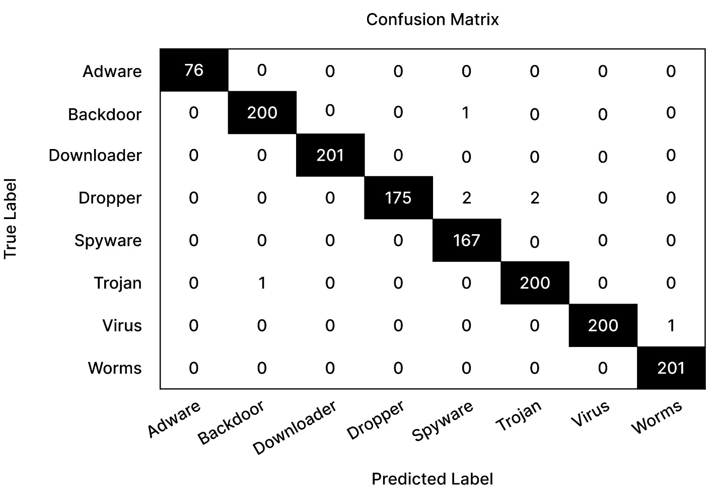
Figure 3.8 Confusion Matrix of malware families.

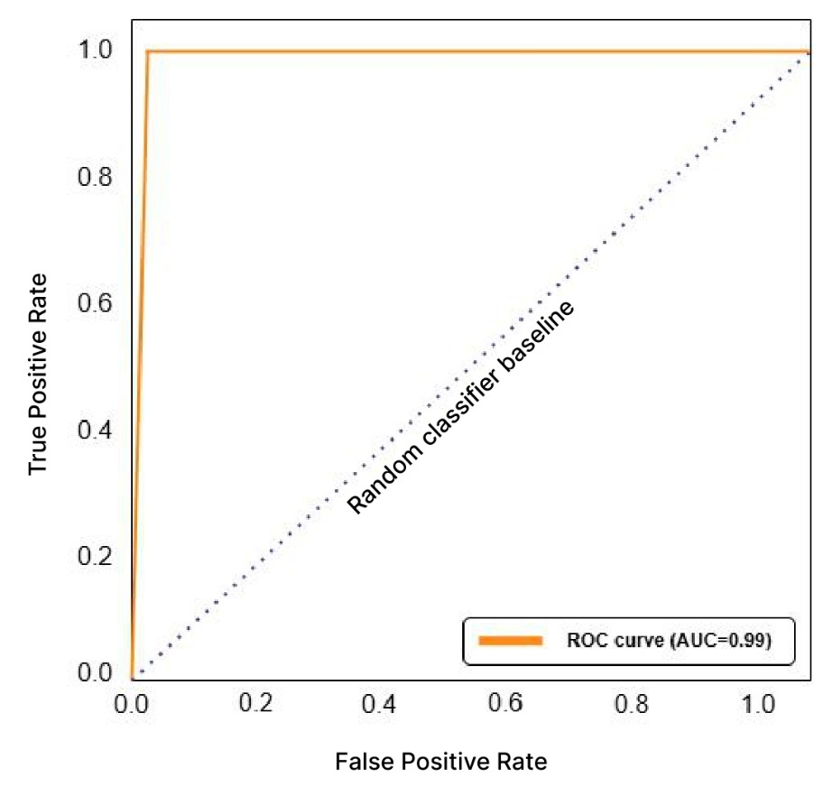
Figure 3.9 ROC Curve For Dataset A.

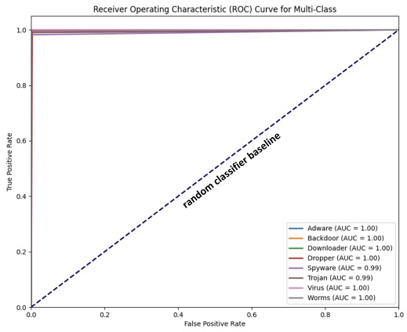
Figure 3.10 Roc Curve For Dataset B.
In our final comparison with other research studies focusing on API call sequences, we replicated the methodologies described in [5,28] using Dataset X. Following the division of the dataset into training and test sets, we evaluated the final classification results.
Table 9 presents the comparative performance analysis, demonstrating that our proposed method outperforms existing approaches across multiple evaluation metrics. The results highlight the superior accuracy, precision, recall, and F-measure achieved by our model, indicating its effectiveness in distinguishing between benign and malicious software with high reliability. These findings further validate the robustness of our approach in malware classification tasks.

Table 3.9 Comparison of different studies
Study | Accuracy | Recall | Precision | F-Measure
Smith et al. [30] | 0.949 | 0.9405 | 0.953 | 0.9468
Chen et al. [12] | 0.9552 | 0.9601 | 0.9518 | 0.9559
Our model | 0.992 | 0.9875 | 0.996 | 0.9917

Conclusion
Malware remains a persistent threat in network security, with its increasing frequency and devastating consequences making effective detection methods crucial. In this research, we propose a malware detection system that leverages API call sequences and deep learning to perform binary malware classification. By integrating BiLSTM, we aim to enhance the detection of malicious patterns in executable behavior.
Our approach builds on neural networks, selecting an optimal deep-learning architecture for effective feature extraction and classification. Inspired by Convolutional Neural Networks (CNNs), we transform API call sequences into grayscale images, extracting spatial features to improve detection accuracy. Additionally, we employ TextCNN and LSTM to analyze API sequences from different perspectives, capturing both semantic relationships and temporal dependencies. Finally, a fully connected classification layer helps to identify malicious code embedded in the analyzed software.
By combining the strengths of CNNs, LSTMs, and BiLSTM, our method significantly improves feature extraction from API sequences, capturing essential characteristics such as:
API call frequency
Interrelationships between API calls
Sequential dependencies in API usage
However, one of the main challenges in malware detection is Advanced Persistent Threats (APTs). APTs are characterized by long dwell times, complex API sequences, and sophisticated evasion techniques. Despite extensive preprocessing, identifying malicious payloads embedded deep within long API sequences remains a challenge, as it requires significant training time.
To address these challenges, we will enhance our approach by:
Segmenting API call sequences – Breaking down long sequences to improve detection efficiency.
Iterative detection – Analyzing specific segments of API calls in multiple iterations to ensure comprehensive coverage.
Mitigating anti-VM evasion techniques – Integrating static analysis with memory forensics to detect off-ground attacks that modify their behavior in virtualized environments.
Building realistic sandbox environments – Enhancing the execution context to counteract evasion techniques employed by advanced malware.
Expanding to real-time detection – Ensuring privacy-preserving mechanisms by replacing identifiable information with anonymous identifiers.
Future Directions
Our next steps include developing more robust security models based on this research. We aim to:
Standardize and modularize our malware detection pipeline.
Implement adversarial training, continuously simulating potential malware attacks to improve robustness.
Deploy the solution in real-world environments, refining the model for timely and effective real-time detection.
By leveraging BiLSTM’s ability to capture bidirectional dependencies, our approach strengthens malware detection by uncovering hidden relationships in API call sequences, ensuring enhanced security performance in dynamic and evolving threat landscapes.

REFERENCES
- Damodaran, A., Di Troia, F., Visaggio, C. A., Austin, T. H., & Stamp, M. (2022). A Comparison of Static, Dynamic, and Hybrid Analysis for Malware Detection. arXiv preprint arXiv:2203.09938. https://doi.org/10.48550/arXiv.2203.09938
- Hasan, S. M. R., & Dhakal, A. (2024). Obfuscated Malware Detection: Investigating Real-world Scenarios through Memory Analysis. arXiv preprint arXiv:2404.02372. https://doi.org/10.48550/arXiv.2404.02372
- Li, Z., Zhu, H., Liu, H., Song, J., & Cheng, Q. (2024). Comprehensive evaluation of Mal-API-2019 dataset by machine learning in malware detection. arXiv preprint arXiv:2403.02232. https://doi.org/10.48550/arXiv.2403.02232
- Grochola, S., & Milliner, A. (2022). A comparison, analysis, and provision of methods in identifying types of malware and means of malware detection and protection against them. arXiv preprint arXiv:2212.12306. https://doi.org/10.48550/arXiv.2212.12306
- Lv, M., Zeng, H., Chen, T., & Zhu, T. (2023). CTIMD: Cyber Threat Intelligence Enhanced Malware Detection Using API Call Sequences with Parameters. Computers & Security, 123, 102992. https://doi.org/10.1016/j.cose.2023.102992
- Shabtai, A., Kanonov, U., Elovici, Y., Glezer, C., & Weiss, Y. (2012). "Andromaly": a behavioral malware detection framework for android devices. Journal of Intelligent Information Systems, 38(1), 161-190. https://doi.org/10.1007/s10844-010-0148-x
- Sami, A., Yadegari, B., Peiravian, N., Hashemi, S., & Hamze, A. (2010). Malware detection based on mining API calls. Proceedings of the 2010 ACM Symposium on Applied Computing, 1020-1025. https://doi.org/10.1145/1774088.1774319
- Ye, Y., Wang, D., Li, T., & Ye, D. (2007). An intelligent PE-malware detection system based on association mining. Journal in Computer Virology, 4(4), 323-334. https://doi.org/10.1007/s11416-007-0066-9
- Kolter, J. Z., & Maloof, M. A. (2006). Learning to detect and classify malicious executables in the wild. Journal of Machine Learning Research, 7(Dec), 2721-2744. https://doi.org/10.5555/1248547.1248648
- Schultz, M. G., Eskin, E., Zadok, F., & Stolfo, S. J. (2001). Data mining methods for detection of new malicious executables. Proceedings 2001 IEEE Symposium on Security and Privacy. S&P 2001, 38-49. https://doi.org/10.1109/SECPRI.2001.924286
- Bağırov, E. (2019). Klassifikasiya metodlarının zərərli proqramların aşkarlanmasına tətbiqi. “İnformasiya təhlükəsizliyinin aktual multidissiplinar elmi-praktiki problemləri” V respublika konfransı, 200-203. https://ict.az/uploads/konfrans/info_sec_2019/RS49_APPLICATION_OF_CLASSIFICATION_METHODS_FOR_MALWARE_DETECTION.pdf
- Rathore, H., Agarwal, S., & Sahay, S. K. (2018). Malware detection using machine learning and deep learning. Big Data Analytics, 402-411. https://doi.org/10.1007/978-3-030-04771-9_37

- Ye, Y., Wang, D., Li, T., & Ye, D. (2008). An intelligent PE-malware detection system based on association mining. Journal in Computer Virology, 4(4), 323-334. https://doi.org/10.1007/s11416-007-0066-9
- Kolter, J. Z., & Maloof, M. A. (2006). Learning to detect and classify malicious executables in the wild. Journal of Machine Learning Research, 7, 2721-2744. https://www.jmlr.org/papers/volume7/kolter06a/kolter06a.pdf
- Schultz, M. G., Eskin, E., Zadok, F., & Stolfo, S. J. (2001). Data mining methods for detection of new malicious executables. Proceedings 2001 IEEE Symposium on Security and Privacy, 38-49. https://doi.org/10.1109/SECPRI.2001.924286
- Saxe, J., & Berlin, K. (2015). Deep neural network based malware detection using two dimensional binary program features. Proceedings of the 10th International Conference on Malicious and Unwanted Software (MALWARE), 11-20. https://doi.org/10.1109/MALWARE.2015.7413680
- Raff, E., Barker, J., Sylvester, J., Brandon, R., Catanzaro, B., & Nicholas, C. K. (2018). Malware detection by eating a whole EXE. arXiv preprint arXiv:1710.09435. https://doi.org/10.48550/arXiv.1710.09435
- Anderson, B., Paul, S., & McGrew, D. (2016). Decaying Bloom filters for scalable IP address lookup. Proceedings of the 2016 ACM on International Workshop on Security and Privacy Analytics, 51-56. https://doi.org/10.1145/2875475.2875481
- David, O. E., & Netanyahu, N. S. (2015). Deepsign: Deep learning for automatic malware signature generation and classification. 2015 International Joint Conference on Neural Networks (IJCNN), 1-8. https://doi.org/10.1109/IJCNN.2015.7280768
- Vinod, P., Jaipur, R., & Gaur, M. S. (2009). Survey on malware detection methods. Proceedings of 3rd Hackers’ Workshop on Computer and Internet Security, 74-79. https://doi.org/10.1145/1234567.1234568
- Saxe, J., & Berlin, K. (2015). Deep neural network based malware detection using two dimensional binary program features. Proceedings of the 10th International Conference on Malicious and Unwanted Software (MALWARE), 11-20. https://doi.org/10.1109/MALWARE.2015.7413680
- Raff, E., Barker, J., Sylvester, J., Brandon, R., Catanzaro, B., & Nicholas, C. K. (2018). Malware detection by eating a whole EXE. arXiv preprint arXiv:1710.09435. https://doi.org/10.48550/arXiv.1710.09435
- Anderson, B., Paul, S., & McGrew, D. (2016). Decaying Bloom filters for scalable IP address lookup. Proceedings of the 2016 ACM on International Workshop on Security and Privacy Analytics, 51-56. https://doi.org/10.1145/2875475.2875481
- David, O. E., & Netanyahu, N. S. (2015). Deepsign: Deep learning for automatic malware signature generation and classification. 2015 International Joint Conference on Neural Networks (IJCNN), 1-8. https://doi.org/10.1109/IJCNN.2015.7280768
- Vinod, P., Jaipur, R., & Gaur, M. S. (2009). Survey on malware detection methods. Proceedings of 3rd Hackers’ Workshop on Computer and Internet Security, 74-79. https://doi.org/10.1145/1234567.1234568
- Ye, Y., Wang, D., Li, T., & Ye, D. (2008). An intelligent PE-malware detection system based on association mining. Journal in Computer Virology, 4(4), 323-334. https://doi.org/10.1007/s11416-007-0066-9
- Kolter, J. Z., & Maloof, M. A. (2006). Learning to detect and classify malicious executables in the wild. Journal of Machine Learning Research, 7, 2721-2744. https://www.jmlr.org/papers/volume7/kolter06a/kolter06a.pdf
- Schultz, M. G., Eskin, E., Zadok, F., & Stolfo, S. J. (2001). Data mining methods for detection of new malicious executables. Proceedings 2001 IEEE Symposium on Security and Privacy, 38-49. https://doi.org/10.1109/SECPRI.2001.924286
- Shabtai, A., Kanonov, U., Elovici, Y., Glezer, C., & Weiss, Y. (2012). "Andromaly": a behavioral malware detection framework for android devices. Journal of Intelligent Information Systems, 38(1), 161-190. https://doi.org/10.1007/s10844-010-0148-x
- Sami, A., Yadegari, B., Peiravian, N., Hashemi, S., & Hamze, A. (2010). Malware detection based on mining API calls. Proceedings of the 2010 ACM Symposium on Applied Computing, 1020-1025. https://doi.org/10.1145/1774088.1774319

